**VISVERVARAYA TECHNOLOGICAL UNIVERSITY**

Jnana Sangama, Belagavi-590018



**DBMS Mini Project Report**

**ON**

**“Forensic And Crime Investigation Management System”**

**Submitted in partial fulfilment of the requirements of 4th Semester (BCS403) Bachelor of Engineering**

**In**

**ARTIFICIAL INTELLIGENCE AND MACHINE LEARNING**

**Submitted By**

**Mohan Gowda G R (1VK22AI024)**

**Nithin Gowda M S (1VK22AI025)**

**Vivek Shivakumar Danaraddi (1VK22AI044)**

**Under the Guidance of**

**Prof. Jamuna H G Assistant Professor,**

**Department of AIML, VKIT**

**VIVEKANANDA INSTITUTE OF TECHNOLOGY**

**Gudimavu, Kumbalgodu(P), Kengeri(H), Bengaluru-560074 2023-2024**

**ACKNOWLEDGEMENT**

An engineer with only theoretical knowledge is not a complete engineer. Practical knowledge is very important to develop and applying engineering skills.

It is my pleasure to be indebted to various people, who directly or indirectly contributed to the development of this work and who influenced my thinking, behaviour and acts during the course of my study.

I wholeheartedly express my sincere thanks to **Dr. K M Ravi Kumar** our beloved Principal, Vivekananda Institute of Technology for the encouragement and support. I also wish to express my deep sense of gratitude to **Dr. Shaila K** Professor and HOD, Department of Artificial Intelligence and Machine Learning Engineering for providing us with all facilities necessary for making DBMS mini-project a great success.

I would like to extend a deep sense of gratitude to our guide **Mrs. Jamuna H G** Assistant Professor, Department of Artificial Intelligence and Machine Learning Engineering for providing us with the required guidance and in preparing the report during DBMS mini-project.

Ultimately, we express our deep sense of gratitude to all the faculty members of VKIT for excellent guidance in our mini-project work.

**DECLARATION**

We, **NITHIN GOWDA M S-(1VK22AI025), MOHAN GOWDA G R-(1VK22AI024) VIVEK SHIVAKUMAR DANARADDI-(1VK22AI044)** of Fourth Semester, Bachelor of Engineering in the Department of Artificial Intelligence and Machine Learning Engineering, Vivekananda Institute of Technology, Bengaluru hereby declare that our DBMS mini-project entitled “**Forensic And Crime Investigation Management System”** has been submitted to the institution. We are herewith submitting the report in partial fulfilment for the award of the degree of Bachelor of Engineering in Artificial Intelligence and Machine Learning Engineering.

**NITHIN GOWDA M S (1VK22AI025)**

**MOHAN GOWDA G R (1VK22AI024)**

**VIVEK S D (1VK22AI044)**

## ABSTRACT

The forensic case management system is a comprehensive platform designed to streamline the process of managing forensic cases, providing essential tools for administrators, forensic lab technicians, and officers. At its core, the system features a robust database schema that efficiently handles user authentication, case management, evidence tracking, and logging activities, ensuring seamless operation and data integrity.

The system includes a user-friendly interface with role-based access control, allowing differentiated access for administrators, lab technicians, and officers. This ensures a secure environment where users can manage cases, enter logs, and handle evidence according to their roles and permissions.

Security is a top priority, with features such as MD5 hashing for password protection and secure session management. The platform also supports image processing for evidence handling, allowing for tasks like resizing, cropping, and comparing forensic images.

The forensic case management system enhances operational efficiency through its structured approach to case management and evidence handling, offering detailed logs and reports that provide insights into case progression and activity history. Future enhancements may include advanced search functionalities, improved notification systems, and integration with external forensic tools.

In summary, the forensic case management system leverages advanced technology, secure design, and comprehensive functionality to support the meticulous process of forensic investigation, making it an invaluable tool for forensic professionals seeking an organized and reliable case management solution.

**Contents**

1. Introduction…………………………………7-8
2. Requirements……………………….............9-9
3. Schema……………………………………...9-9
4. Future Scope……………………………...10-10
5. Implementation…………………………..10-12
6. Tools and Software Used…………………12-14
7. Complexity………………………………..15-17
8. Errors and Their Fixes…………………….17-34
9. References…………………………………34-34
10. Result………………………………………34-34

**Introduction**

In the realm of forensic science, the meticulous management of cases, evidence, and related data is paramount to the integrity and efficiency of criminal investigations. A forensic case management system serves as a vital tool in this domain, providing a centralized platform for organizing and handling the intricate details involved in forensic casework. The project at hand focuses on the development of a robust forensic case management system, designed to streamline and enhance the entire workflow associated with forensic investigations. This system is crafted to support both administrative and technical functions, facilitating seamless communication and coordination between administrators and forensic lab technicians.

The impetus for developing this system stems from the need for a comprehensive solution that addresses the challenges of managing large volumes of forensic data and ensuring the accuracy and reliability of case documentation. Traditional methods of managing forensic cases often involve disparate systems and manual processes, which can lead to inefficiencies, errors, and delays. In contrast, a dedicated forensic case management system provides an integrated approach, allowing for the efficient handling of case records, evidence logs, and laboratory results. By automating many of the routine tasks associated with forensic case management, the system reduces the administrative burden on staff, enabling them to focus more on the critical aspects of forensic analysis and interpretation.

One of the primary objectives of this project is to create a user-friendly interface that caters to the specific needs of forensic professionals. The system is designed to be intuitive, with a focus on ease of navigation and accessibility. This ensures that both experienced users and those new to the system can quickly adapt to its features and functionalities. The design considerations also include robust security measures to protect sensitive information, as the nature of forensic work often involves handling confidential and potentially incriminating data. Ensuring the integrity and security of this data is of utmost importance, and the system incorporates advanced authentication protocols and access controls to safeguard against unauthorized access and data breaches.

The system is equipped to handle a wide range of functionalities, tailored to the distinct roles within a forensic laboratory. For administrators, the system offers tools for managing user permissions, overseeing case progress, and maintaining an overview of the lab's workflow. This oversight capability is crucial for ensuring that cases are processed in a timely manner and that all procedures adhere to established protocols and legal standards. For forensic lab technicians, the system provides a comprehensive suite of tools for logging evidence, documenting lab results, and managing case files. The ability to upload and associate digital files, such as photographs and documents, with specific cases enhances the comprehensiveness of the case records, providing a thorough documentation trail.

In addition to the core functionalities, the system is designed to support robust reporting and analysis features. These capabilities allow users to generate detailed reports, track the status of ongoing cases, and analyse trends in forensic data. Such features are invaluable for both internal audits and external reviews, ensuring transparency and accountability in the forensic process. The ability to quickly generate and share reports also facilitates communication with law enforcement, legal professionals, and other stakeholders, enhancing the overall efficiency and effectiveness of the forensic investigation process.

The development of this forensic case management system represents a significant step forward in the modernization of forensic laboratories. By providing a centralized, automated platform for managing the complex workflows associated with forensic casework, the system not only improves operational efficiency but also enhances the quality and reliability of forensic analysis. As the field of forensic science continues to evolve, the adoption of advanced case management systems like this one will be crucial in maintaining the highest standards of accuracy, security, and professionalism in forensic investigations.

In conclusion, the forensic case management system developed in this project is a comprehensive solution designed to meet the unique needs of forensic laboratories. By streamlining the processes of case management, evidence handling, and data documentation, the system offers significant benefits in terms of efficiency, accuracy, and security. This introduction provides an overview of the system's purpose and functionalities, setting the stage for a detailed exploration of its features and impact in subsequent sections.

**Requirements**

The forensic case management system requires the following components:

* **Hardware Requirements**:
  + A computer with a minimum of 4GB RAM
  + At least 500GB of storage space
  + A stable internet connection
* **Software Requirements**:
  + XAMPP (or any equivalent web server solution stack package)
  + A web browser (e.g., Google Chrome, Mozilla Firefox)
  + PHP 7.x or higher
  + MySQL 5.x or higher

**Schema**

The database schema consists of multiple tables to handle different aspects of the forensic case management system. Below is a brief overview of the tables:

1. **Users**: This table stores the details of users including administrators, forensic lab technicians, and officers.
   * Fields: user_id, username, password, role, created_at
2. **Cases**: This table contains information about each forensic case.
   * Fields: case_id, title, description, status, assigned_to, created_at, updated_at
3. **Logs**: This table records all the logs related to each case.
   * Fields: log_id, case_id, log_entry, created_at
4. **Evidence**: This table holds the details of all evidence related to the cases.
   * Fields: evidence_id, case_id, evidence_type, description, collected_by, collected_at
5. **Departments**: This table contains information about the different departments involved.
   * Fields: department_id, department_name

**Future Scope**

The following enhancements can be considered for future development:

* Implementing a more advanced search functionality to filter cases and evidence based on various criteria.
* Adding a notification system to alert users of updates or changes to cases.
* Enhancing the user interface for better user experience.
* Integrating with external forensic tools and databases for more comprehensive case management.

## Implementation

The forensic case management system was implemented using PHP for server-side scripting, MySQL for database management, and HTML/CSS/JavaScript for the front-end. The implementation process is divided into several modules, each handling specific functionalities of the system.

### **1. User Authentication**

**Files:** login_submit.php, logout_script.php, signup_script.php

* Users (administrators, forensic lab technicians, officers) can sign up, log in, and log out of the system.
* User credentials are verified against the entries in the Users table.
* Sessions are managed to maintain user login states.

### **2. Case Management**

**Files:** admincases.php, assigncases.php, caseclosed.php, caseopen.php, casepending.php, casereopen.php, caseupdate.php, caseview.php

* Administrators and forensic lab technicians can create, update, and manage forensic cases.
* Each case includes details such as title, description, status, and assigned personnel.
* Cases are stored in the Cases table, and their statuses can be updated as needed.

### **3. Log Management**

**Files:** entrylogs.php, logs.php, amendedlogs.php, inscribedlogs.php

* All actions related to cases are logged and stored in the Logs table.
* Users can view logs to track the history of actions performed on each case.
* Logs include details such as the log entry, associated case, and timestamps.

### **4. Evidence Management**

**Files:** insertevidences.php, insertfirearms.php, insertknownforensics.php, insertsuspects.php

* Evidence related to cases is recorded and managed within the system.
* Evidence details are stored in the Evidence table, including type, description, and collection details.
* The system allows users to input and retrieve evidence information easily.

### **5. User and Role Management**

**Files:** users.php, usersdelete.php, usersview.php, settings.php, settings_script.php

* Administrators can manage user accounts and roles.
* User details and roles are stored in the Users table.
* Roles define the permissions and access levels of different users within the system.

### **6. Interface and Navigation**

**Files:** home.php, adminhome.php, officerhome.php, lab.php, labtech.php, labview.php, labwrite.php, officerview.php, officerwrite.php

* The user interface is designed for easy navigation and interaction with the system.
* Different dashboards are provided for administrators, forensic lab technicians, and officers.
* Navigation menus and links allow users to access various functionalities of the system.

### **7. Notifications and Alerts**

**Files:** success.php, failed.php, capture.php

* The system includes basic notification mechanisms to inform users of successful or failed actions.
* Notifications are displayed as alerts or messages on the user interface.

### **8. Database Structure**

**Files:** sql

* The database schema was designed to support the functionalities of the forensic case management system.
* The schema includes tables such as Users, Cases, Logs, Evidence, and Departments.
* SQL scripts were used to create and manage these tables in MySQL.

### **9. Additional Features**

**Files:** contact.php, credential.php, storeImage.php, image.compare.class.php

* Additional features include contact forms, credential management, and image comparison functionalities.
* These features enhance the overall usability and effectiveness of the forensic case management system.

## Tools and Software Used

The forensic case management system utilizes a variety of tools and software to achieve its functionality. Below is a brief overview of the key technologies employed:

### 1. **PHP**

* **Description**: PHP (Hypertext Preprocessor) is a widely-used open-source scripting language designed for web development. It is embedded in HTML and is used to manage dynamic content, databases, session tracking, and more.
* **Role in Project**: PHP is used for server-side scripting, handling form submissions, processing user inputs, and interacting with the MySQL database.

### 2. **MySQL**

* **Description**: MySQL is an open-source relational database management system (RDBMS) that uses Structured Query Language (SQL) for managing and manipulating databases.
* **Role in Project**: MySQL stores all the data related to users, cases, logs, evidence, and departments. It handles data queries, updates, and ensures data integrity.

### 3. **Apache**

* **Description**: Apache HTTP Server is a free and open-source web server software that enables the delivery of web content via the internet.
* **Role in Project**: Apache serves as the web server, hosting the PHP scripts and serving web pages to users. It handles HTTP requests and responses between the client and server.

### 4. **CSS and Bootstrap**

* **Description**: CSS (Cascading Style Sheets) is used for describing the presentation of a document written in HTML. Bootstrap is a popular open-source CSS framework for developing responsive and mobile-first websites.
* **Role in Project**: CSS and Bootstrap are used to style the web pages, ensuring a consistent and responsive design across different devices and screen sizes.

### 5. **JavaScript**

* **Description**: JavaScript is a lightweight, interpreted programming language known for making web pages interactive. It is commonly used alongside HTML and CSS.
* **Role in Project**: JavaScript is used to enhance the interactivity of the web pages, such as form validation, dynamic content updates, and user interface enhancements.

### 6. **HTML**

* **Description**: HTML (HyperText Markup Language) is the standard markup language for creating web pages and web applications.
* **Role in Project**: HTML is used to structure the content of the web pages, defining elements such as headings, paragraphs, forms, and links.

### 7. **MD5**

* **Description**: MD5 (Message-Digest Algorithm 5) is a widely used cryptographic hash function that produces a 128-bit hash value. It is commonly used to verify data integrity.
* **Role in Project**: MD5 is used for hashing passwords before storing them in the database, providing a layer of security to protect user credentials.

### 8. **PHP Image Processing**

* **Description**: PHP provides built-in functions and libraries (e.g., GD library) for image processing tasks such as resizing, cropping, and comparing images.
* **Role in Project**: PHP image processing is used for handling and manipulating images uploaded as evidence, including functionalities for image comparison.

### 9. **PHPMailer**

* **Description**: PHPMailer is a PHP library that provides a flexible and robust solution for sending emails from a web server.
* **Role in Project**: PHPMailer is used to handle email notifications and alerts within the system, such as sending confirmation emails to users.

**Relational Diagram**

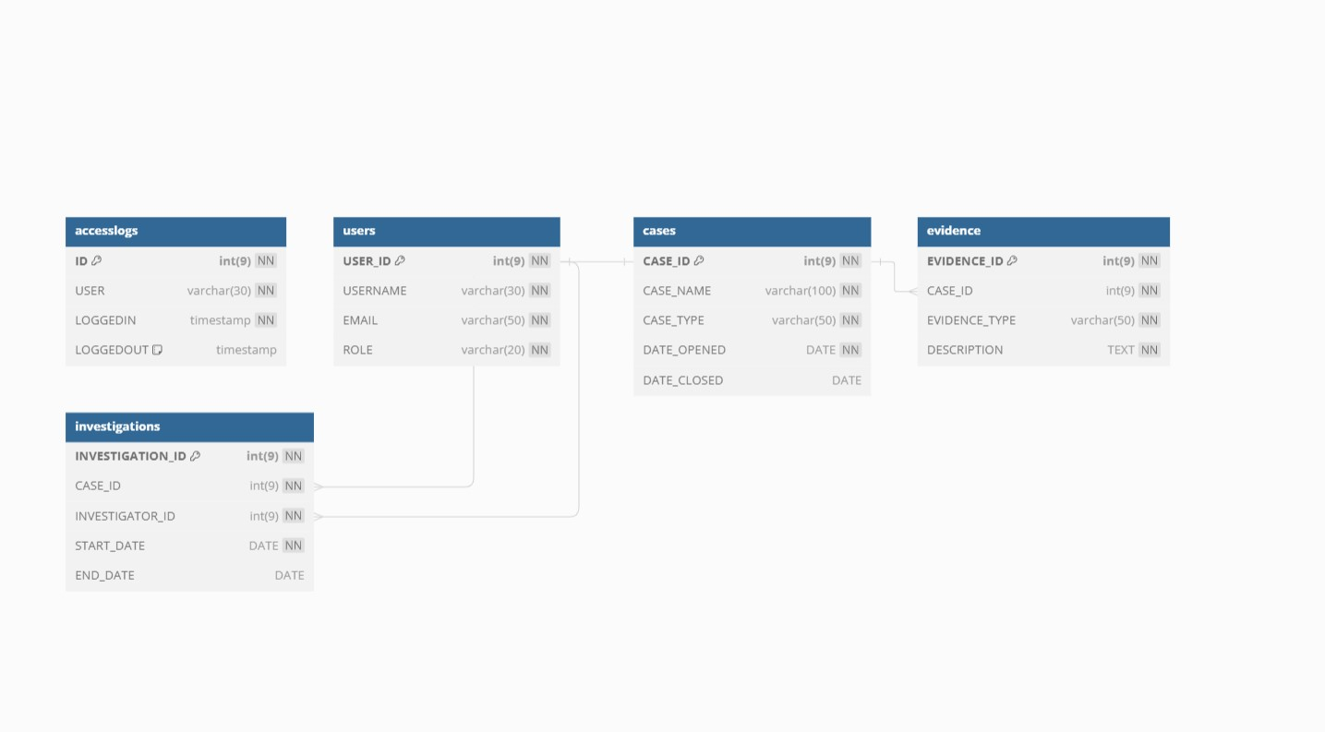

## Relational Diagram (Figure-1)

## Complexity

The forensic case management system involves moderate complexity due to its multiple interconnected modules and functionalities. Here are some key factors contributing to the complexity:

### 1. **User Authentication and Role Management**

* **Complexity**: Moderate
* **Reason**: Implementing secure authentication and role-based access control requires careful handling of user credentials, session management, and permission checks.

### 2. **Case Management**

* **Complexity**: Moderate
* **Reason**: Managing the lifecycle of forensic cases (creation, updating, closing, reopening) involves multiple states and interactions between different user roles. Ensuring data consistency and integrity across various case statuses adds to the complexity.

### 3. **Log Management**

* **Complexity**: Moderate
* **Reason**: Maintaining a detailed log of actions performed on each case involves recording, storing, and retrieving log entries efficiently. This requires a well-structured logging mechanism and database design.

### 4. **Evidence Management**

* **Complexity**: High
* **Reason**: Handling various types of evidence (e.g., physical evidence, digital evidence) with detailed attributes and ensuring proper linkage to cases involves complex database schema design and validation logic.

### 5. **Database Design and Management**

* **Complexity**: High
* **Reason**: Designing a normalized database schema that can efficiently store and manage users, cases, logs, evidence, and departments requires careful planning. Ensuring data integrity and optimizing queries for performance adds to the complexity.

### 6. **Interface and User Experience**

* **Complexity**: Moderate
* **Reason**: Developing a user-friendly interface that provides easy navigation and interaction for different user roles requires thoughtful design and front-end development skills. Ensuring a consistent and intuitive user experience is essential.

### 7. **Notifications and Alerts**

* **Complexity**: Low
* **Reason**: Implementing basic notification mechanisms to inform users of successful or failed actions is relatively straightforward but still requires proper handling of user feedback.

### 8. **Security Considerations**

* **Complexity**: High
* **Reason**: Ensuring the system is secure from common web vulnerabilities (e.g., SQL injection, cross-site scripting) involves implementing best practices in coding, input validation, and user authentication. Protecting sensitive forensic data is critical.

### 9. **Additional Features**

* **Complexity**: Variable
* **Reason**: Additional features such as image comparison, contact forms, and credential management can vary in complexity based on the level of functionality and integration required.

### 10. **Scalability and Maintenance**

* **Complexity**: Moderate
* **Reason**: Designing the system to be scalable and maintainable over time requires foresight in code organization, modularity, and documentation. Ensuring the system can handle increased load and future enhancements is important.

**Errors and Their Fixes**

**Code Adjustment for Image Comparison Class**

After enabling the GD extension, ensure the image comparison class functions properly:

**Updated image.compare.class.php:**

php

Copy code

<?php

class compareImages

{

private function mimeType($i)

{

$mime = getimagesize($i);

$return = array($mime[0], $mime[1]);

switch ($mime['mime'])

{

case 'image/jpeg':

$return[] = 'jpg';

return $return;

case 'image/png':

$return[] = 'png';

return $return;

default:

return false;

}

}

private function createImage($i)

{

$mime = $this->mimeType($i);

if ($mime[2] == 'jpg')

{

return imagecreatefromjpeg($i);

}

else if ($mime[2] == 'png')

{

return imagecreatefrompng($i);

}

else

{

return false;

}

}

private function resizeImage($i, $source)

{

$mime = $this->mimeType($source);

$t = imagecreatetruecolor(8, 8);

$source = $this->createImage($source);

imagecopyresized($t, $source, 0, 0, 0, 0, 8, 8, $mime[0], $mime[1]);

return $t;

}

private function colorMeanValue($i)

{

$colorList = array();

$colorSum = 0;

for ($a = 0; $a < 8; $a++)

{

for ($b = 0; $b < 8; $b++)

{

$rgb = imagecolorat($i, $a, $b);

$colorList[] = $rgb & 0xFF;

$colorSum += $rgb & 0xFF;

}

}

return array($colorSum / 64, $colorList);

}

private function bits($colorMean)

{

$bits = array();

foreach ($colorMean[1] as $color) { $bits[] = ($color >= $colorMean[0]) ? 1 : 0; }

return $bits;

}

public function compare($a, $b)

{

$i1 = $this->createImage($a);

$i2 = $this->createImage($b);

if (!$i1 || !$i2) { return false; }

$i1 = $this->resizeImage($i1, $a);

$i2 = $this->resizeImage($i2, $b);

imagefilter($i1, IMG_FILTER_GRAYSCALE);

imagefilter($i2, IMG_FILTER_GRAYSCALE);

$colorMean1 = $this->colorMeanValue($i1);

$colorMean2 = $this->colorMeanValue($i2);

$bits1 = $this->bits($colorMean1);

$bits2 = $this->bits($colorMean2);

$hammeringDistance = 0;

for ($a = 0; $a < 64; $a++)

{

if ($bits1[$a] != $bits2[$a])

{

$hammeringDistance++;

}

}

return $hammeringDistance;

}

}

?>

**Conclusion Of The Error’s**

By enabling the GD extension in PHP and ensuring correct handling of file paths and uploads, the encountered errors were resolved, allowing the forensic image comparison functionality to work as intended.

**FINAL PRODUCT**

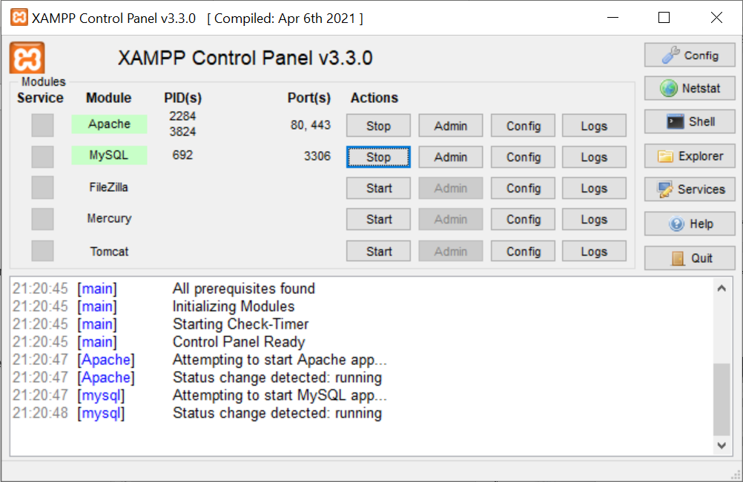

**Xamp control panel (Figure-2)**

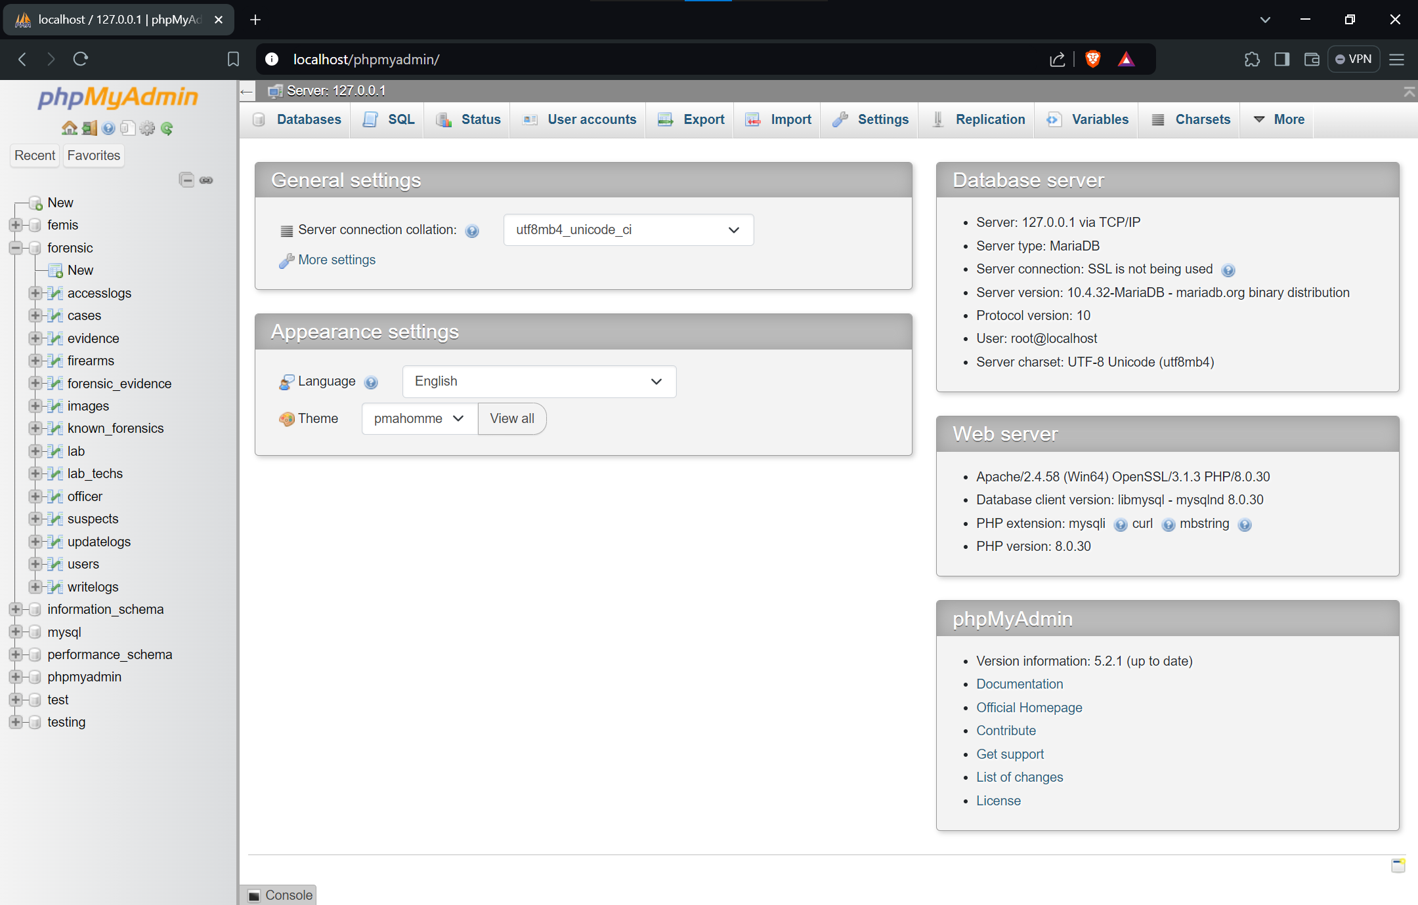

**PHP admin page (Figure-3)**

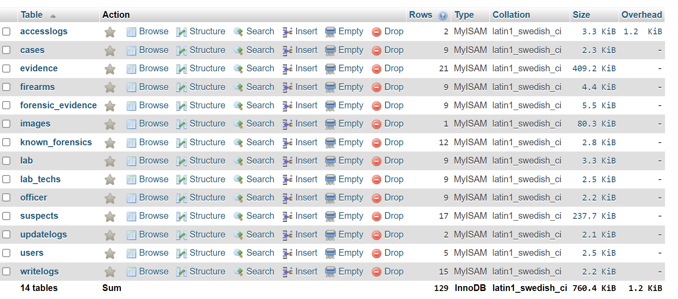

**Forensic Database (Figure-4)**

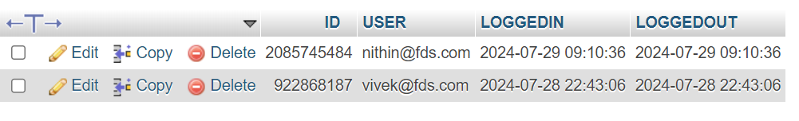

**Access log database (Figure-5)**

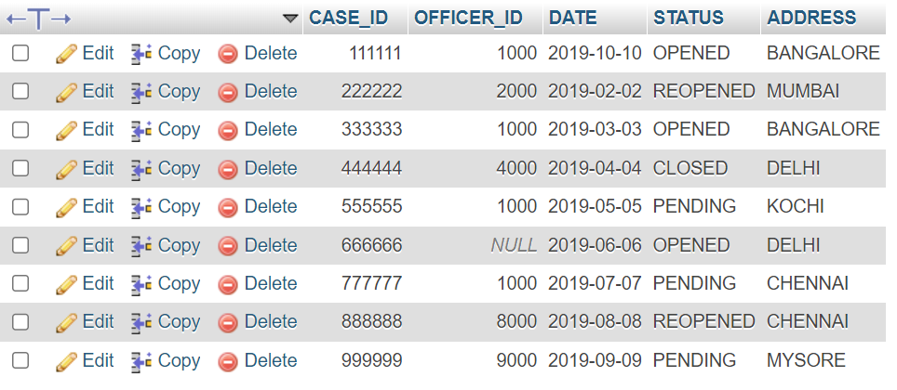

**Cases Database (Figure-6)**

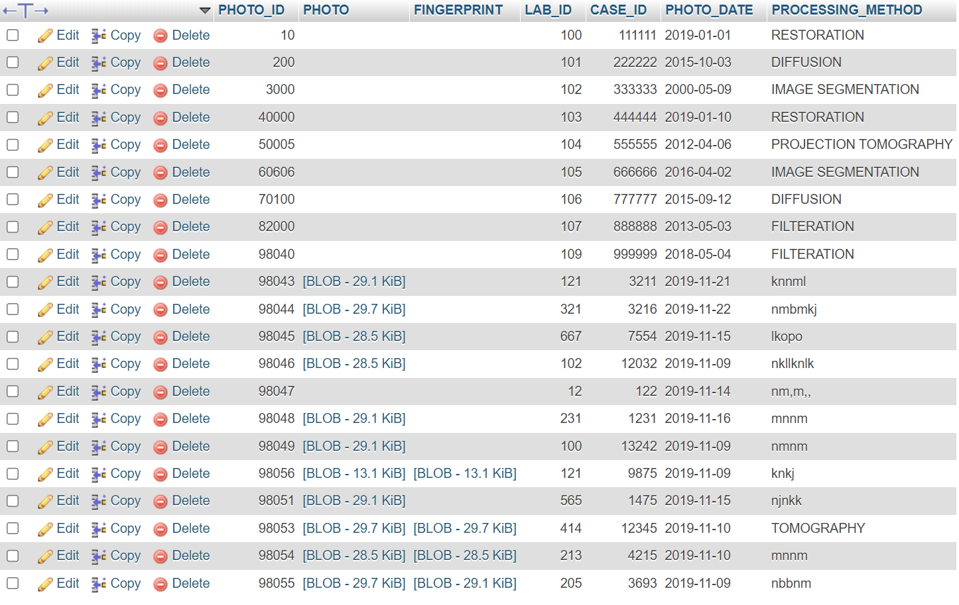

**Evidence Database (Figure-7)**

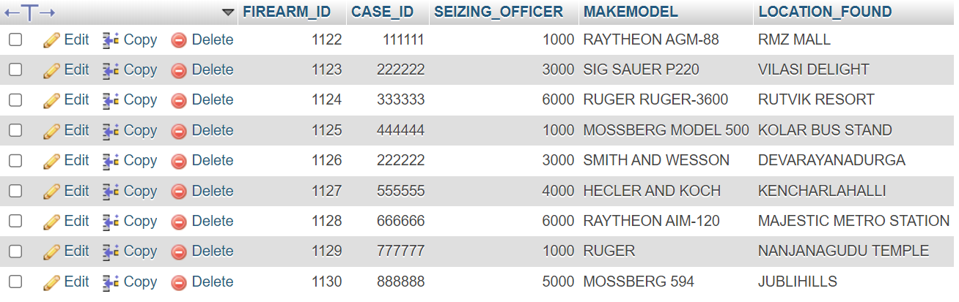

**Firearms Database (Figure-8)**

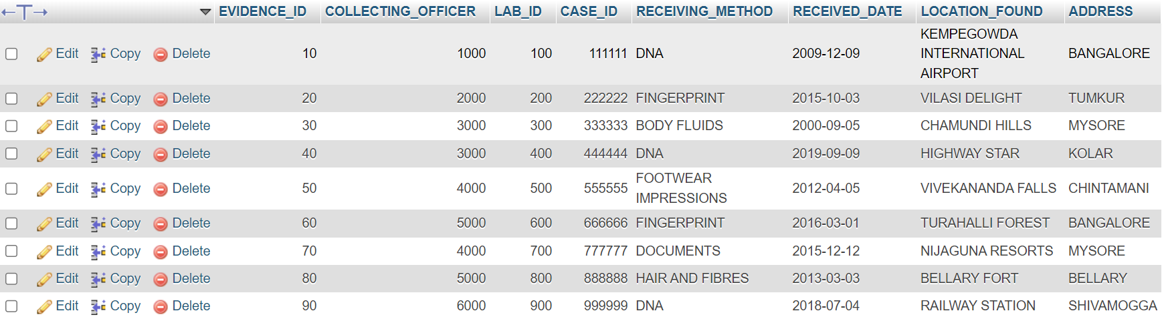

**Forensic Evidence Database (Figure-9)**

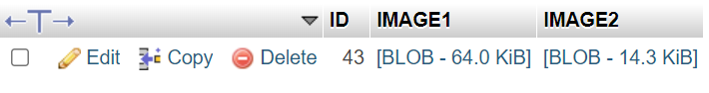

**Cases Image Database (Figure-10)**

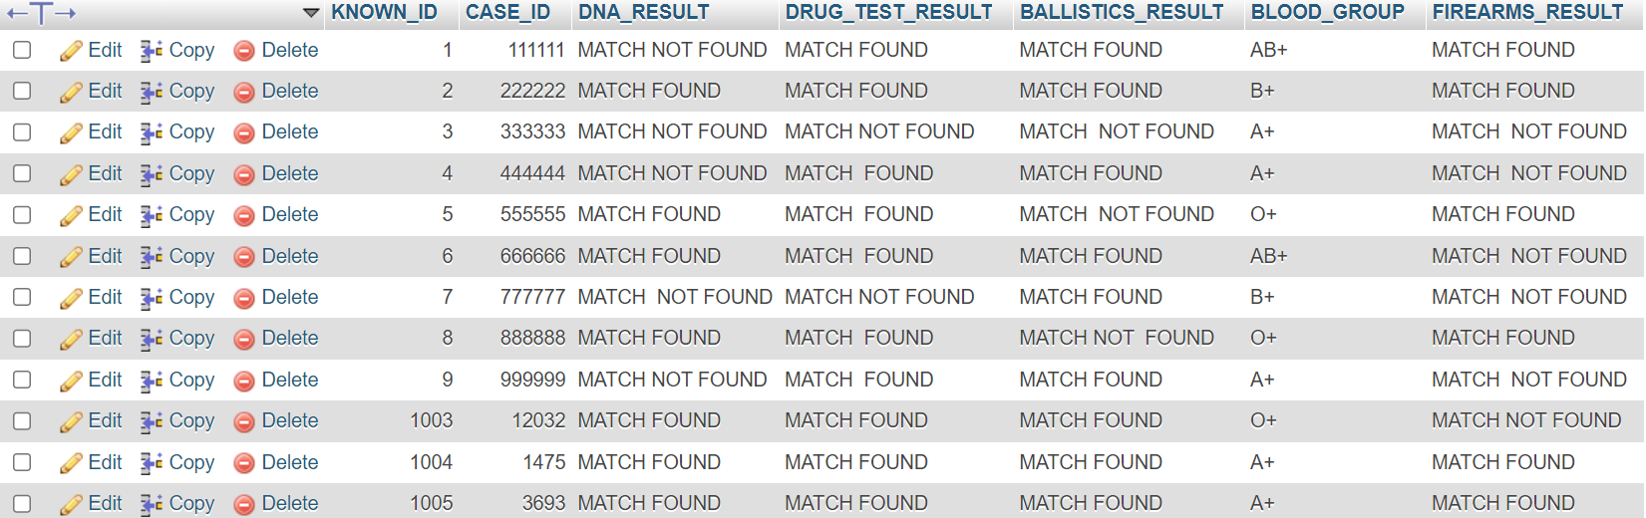

**Known Forensic Database (Figure-11)**

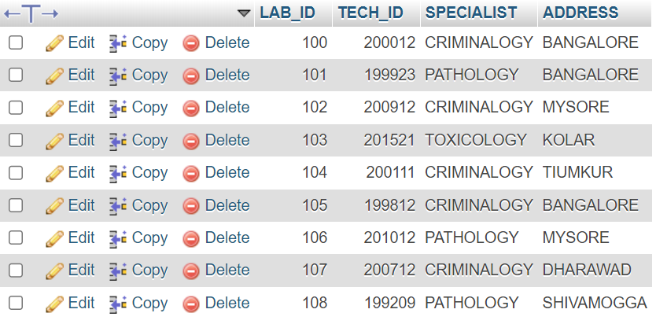

**Lab Database (Figure-12)**

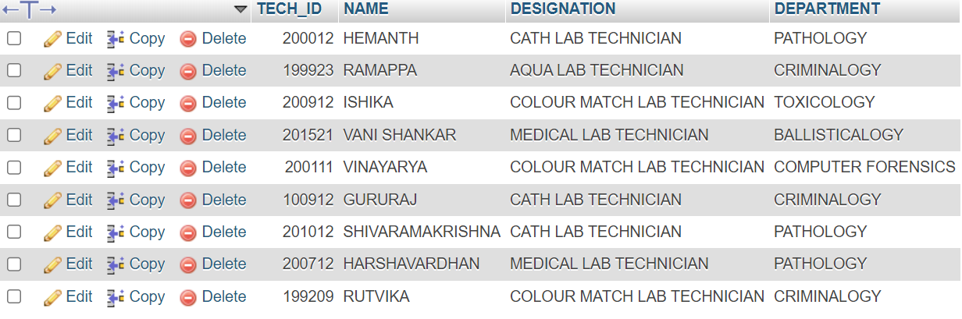

**LabTech Database (Figure-13)**

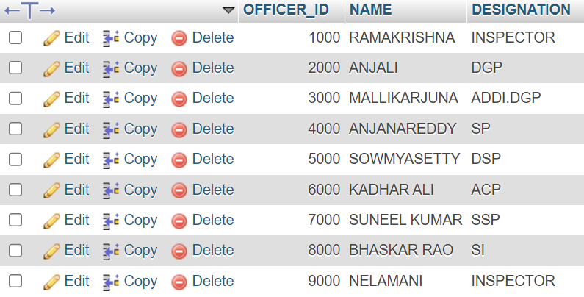

**Officers Database (Figure-14)**

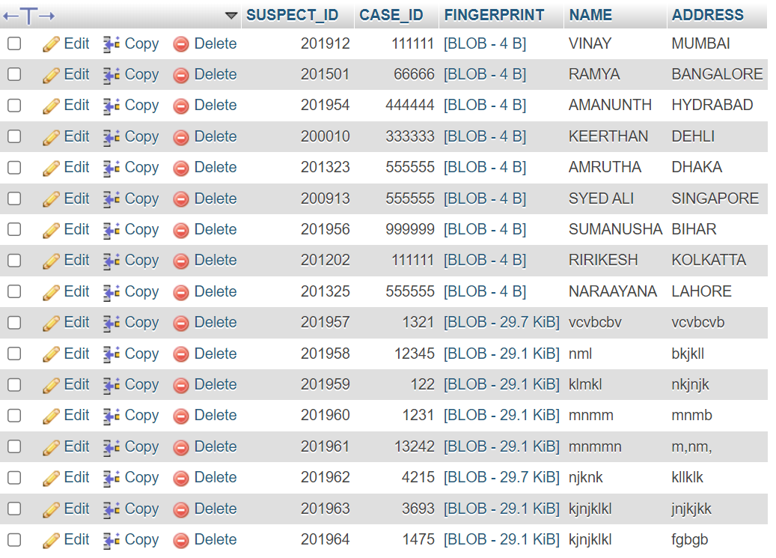

**Suspects Database (Figure-15)**

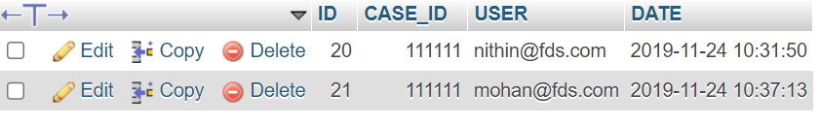

**Users Database (Figure-16)**

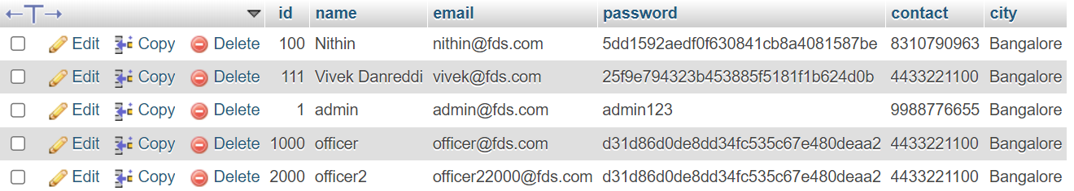

**User Database (Figure-17)**

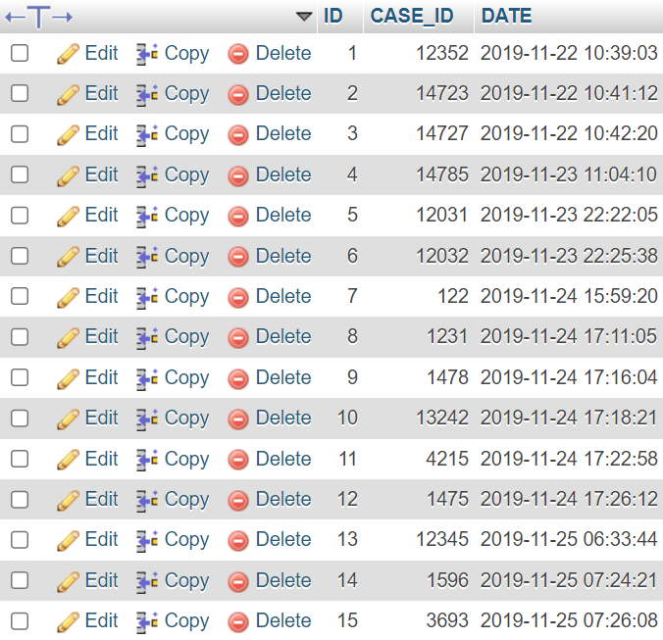

**Case Write Logs (Figure-18)**

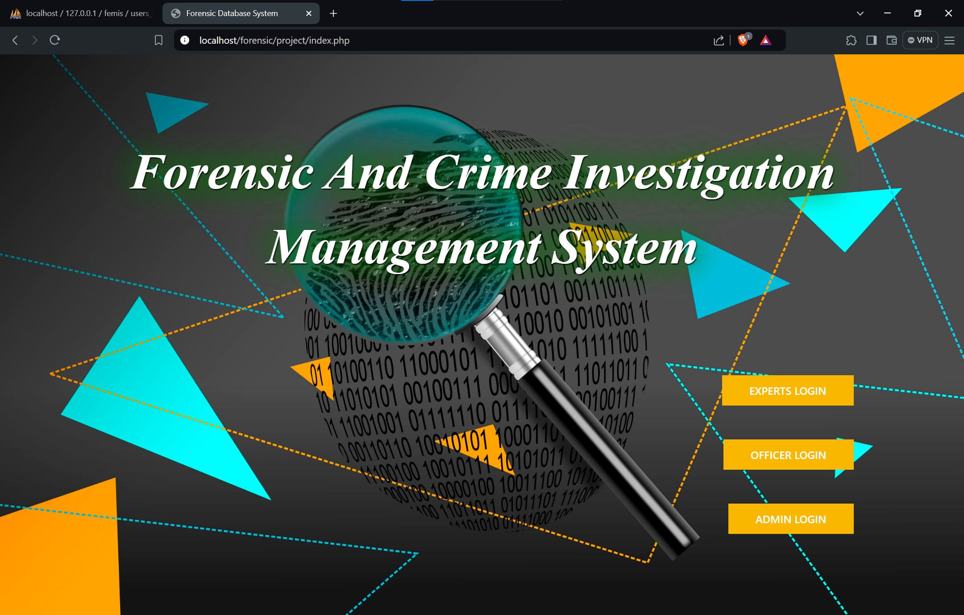

**Main Page (Figure-19)**

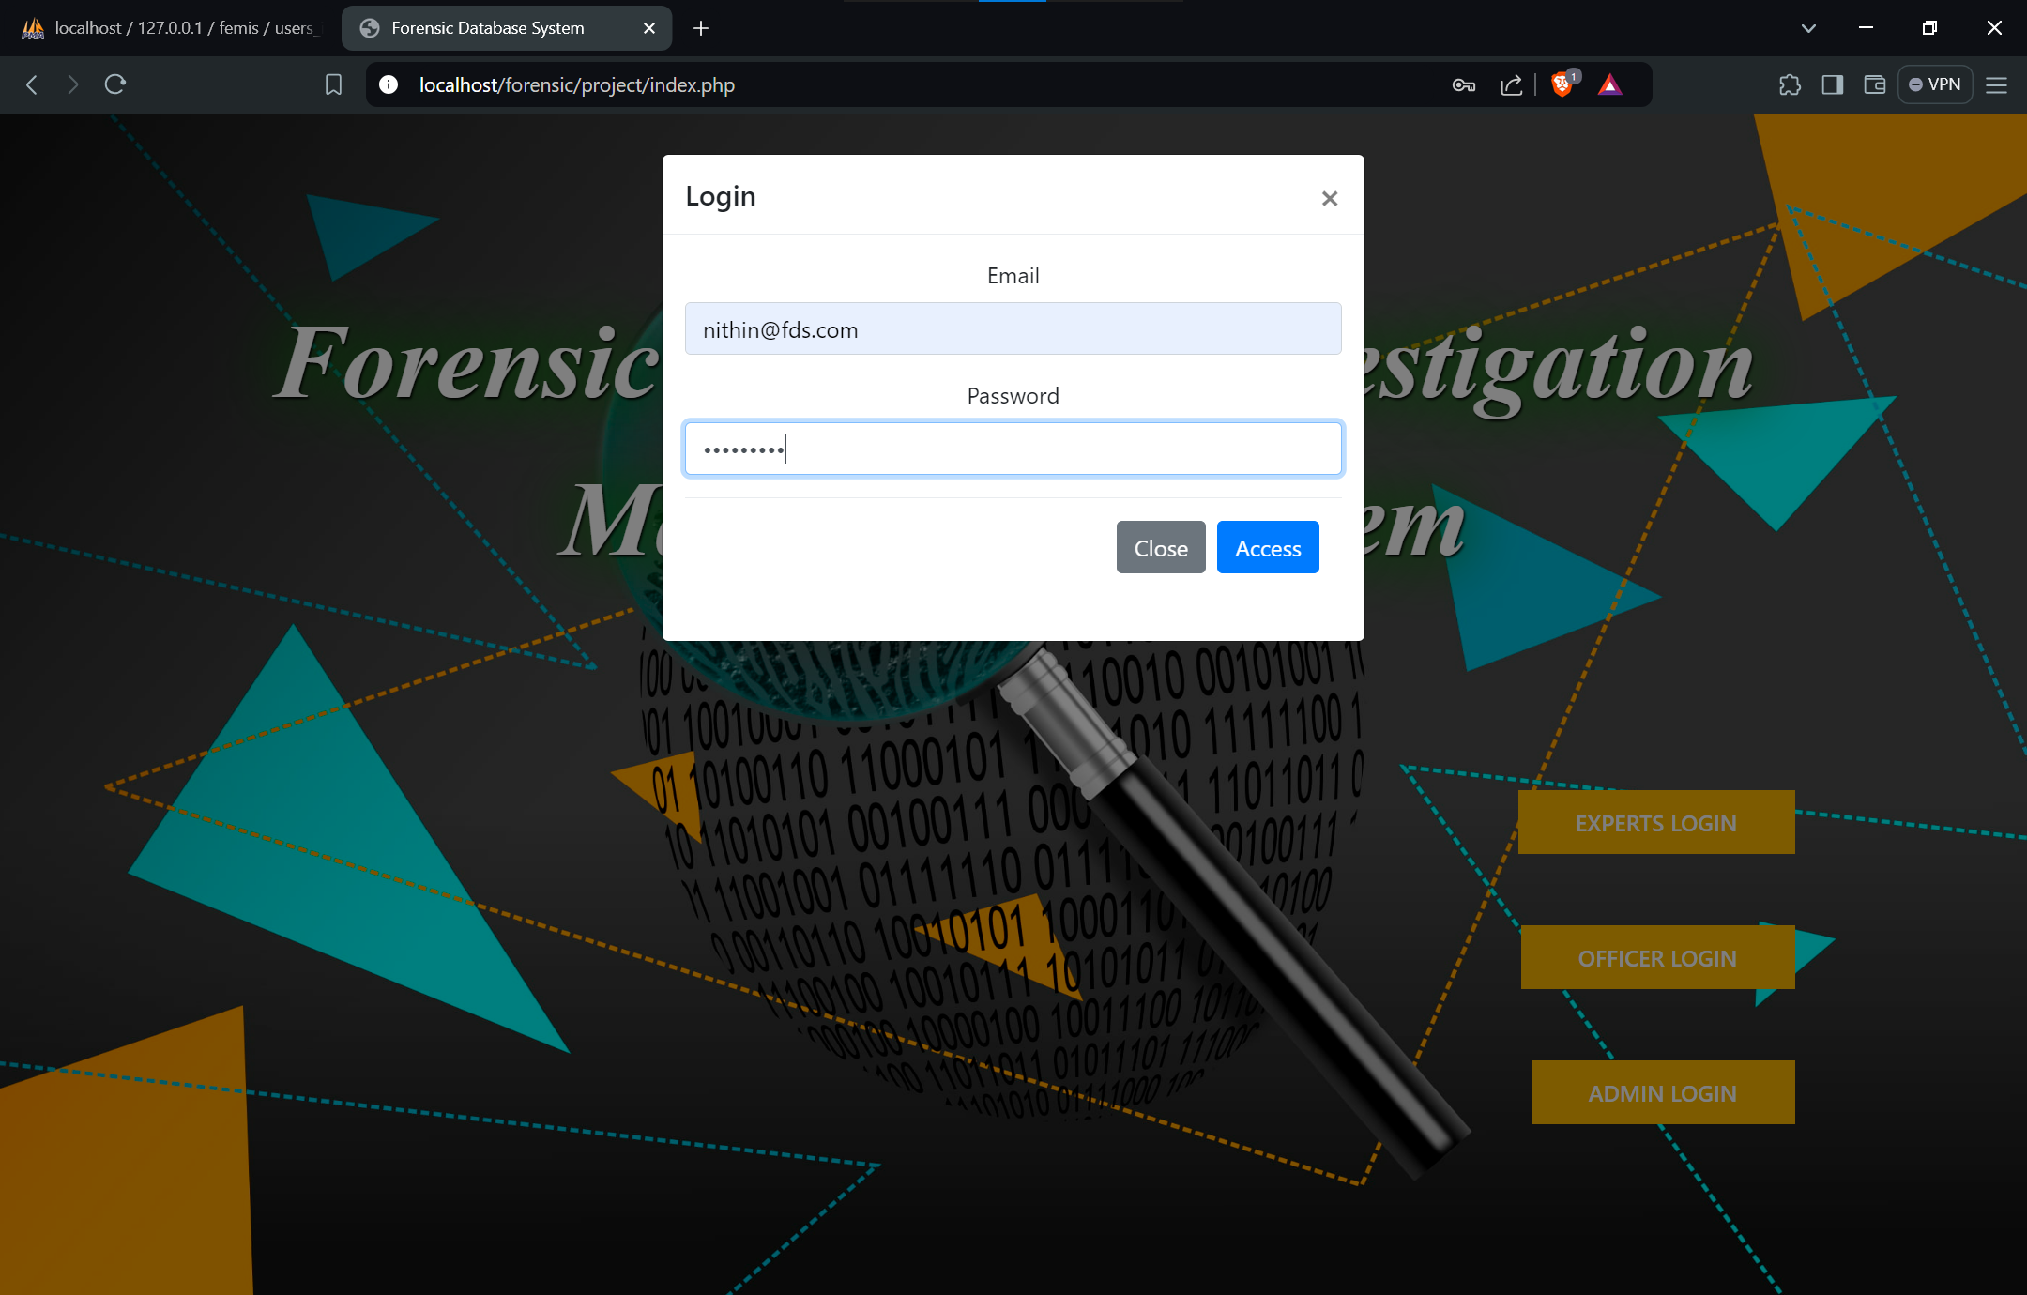

**Login Page (Figure-20)**

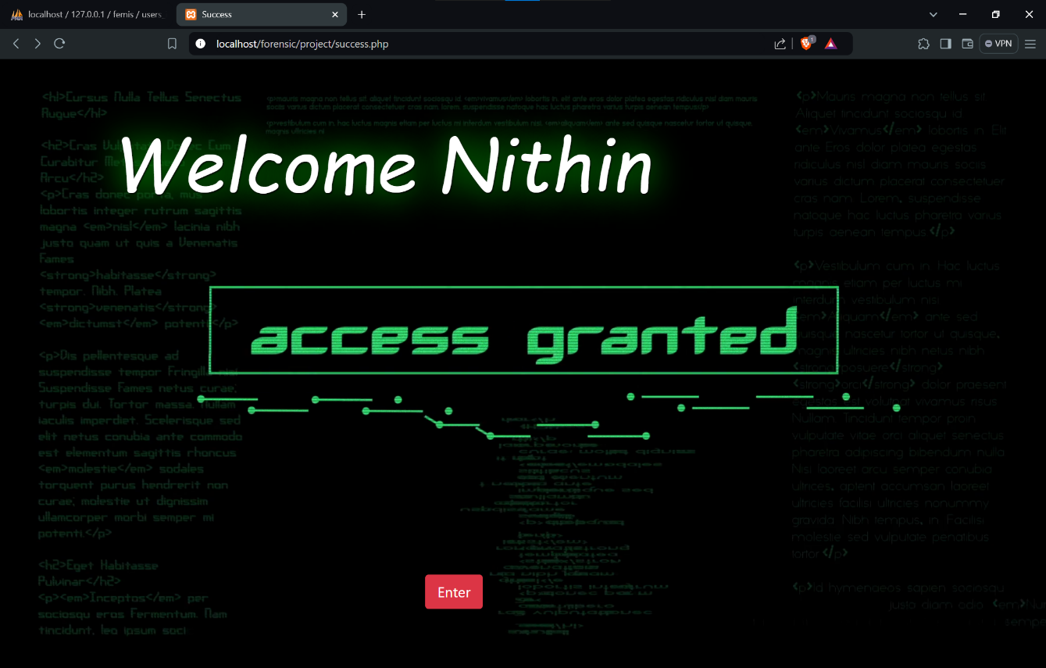

**Successful login page (Figure-21)**

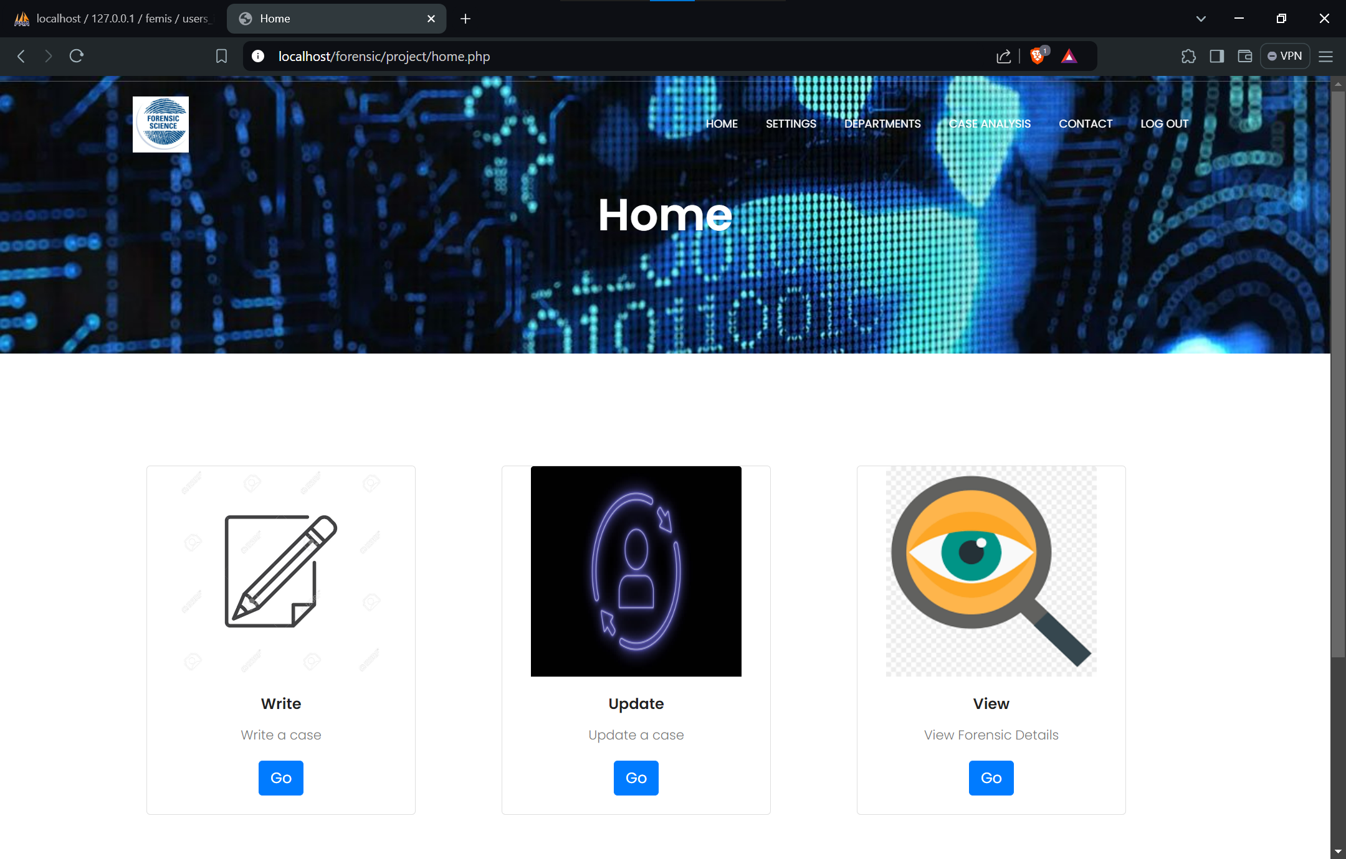

**Homepage (Figure-22)**

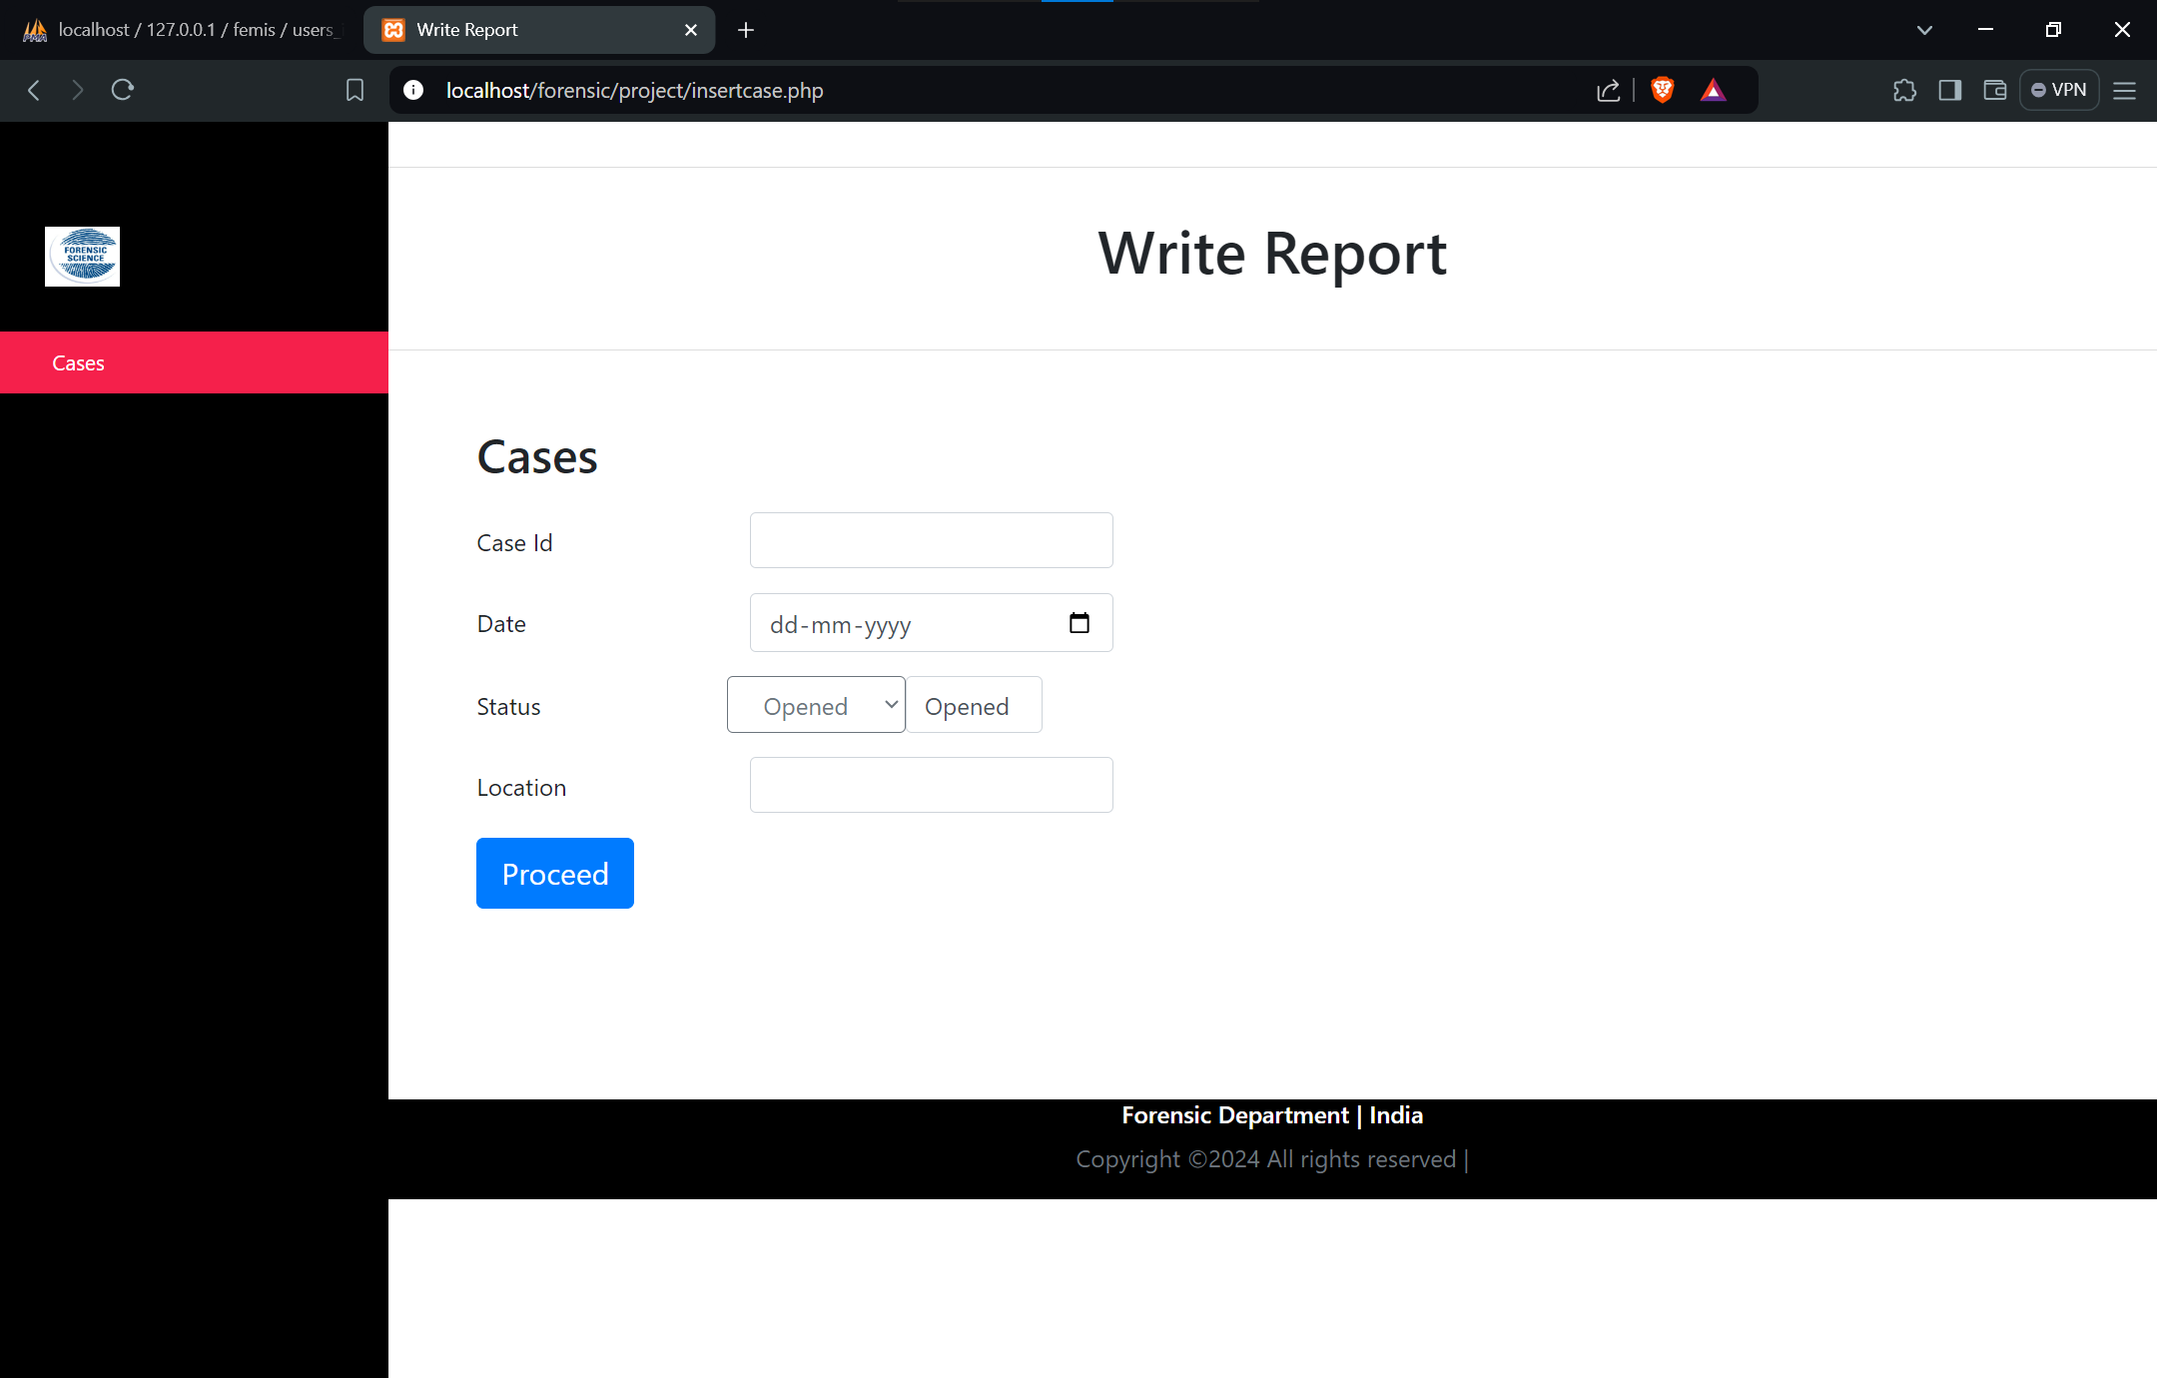

**Report Writing Page (Figure-23)**

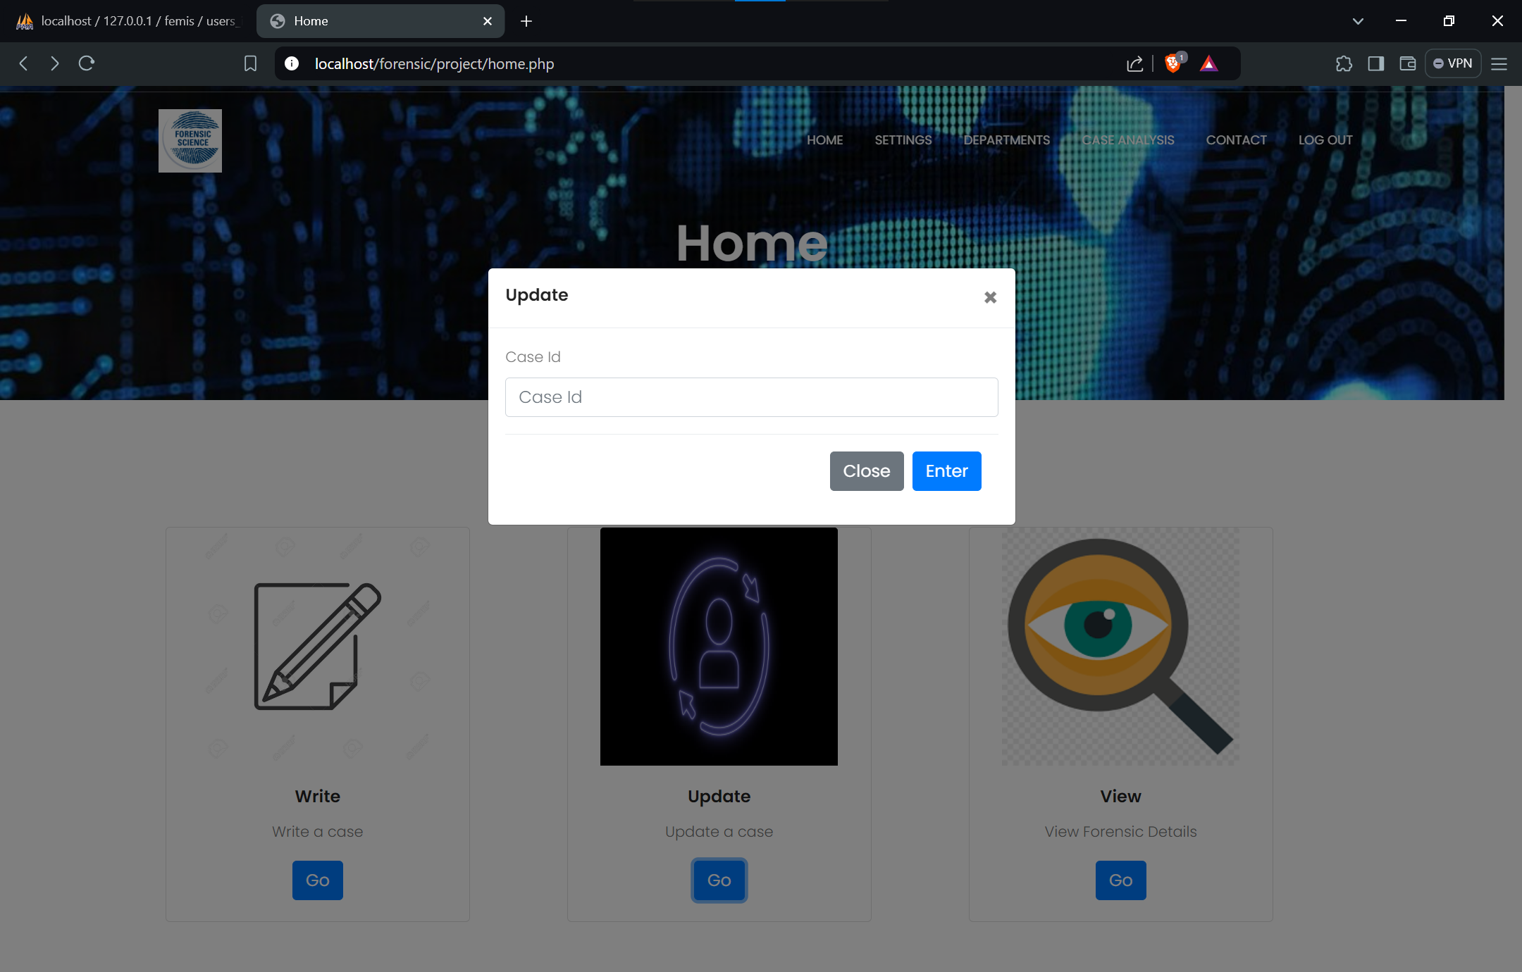

**Update option (Figure-24)**

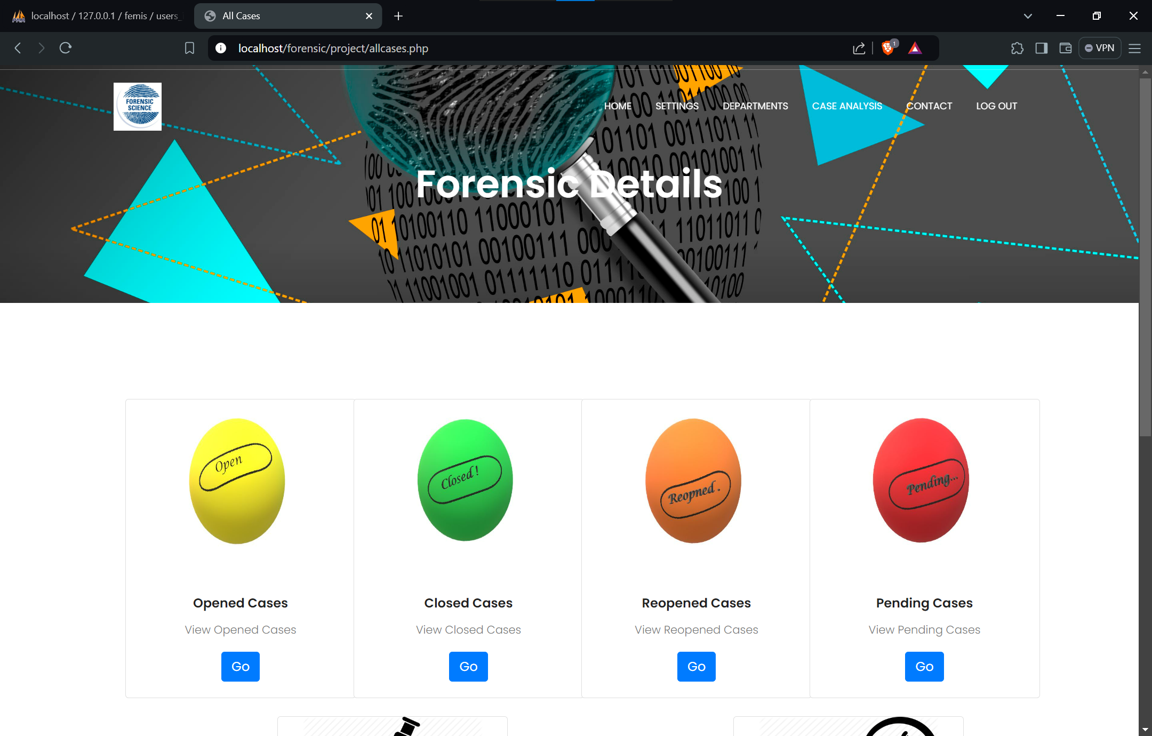

**View Forensic (Figure-25.1)**

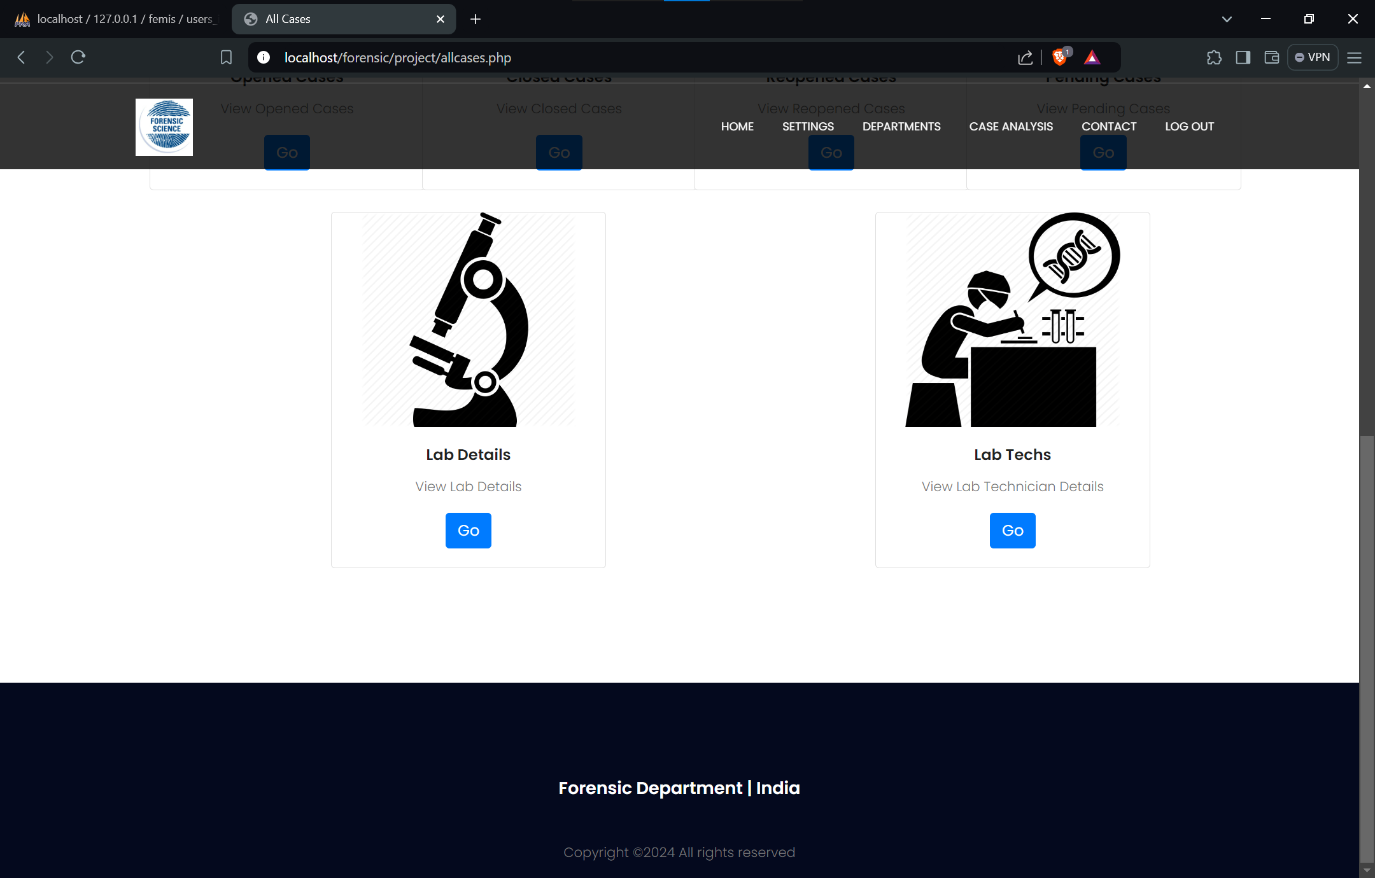

**View Forensic (Figure-25.2)**

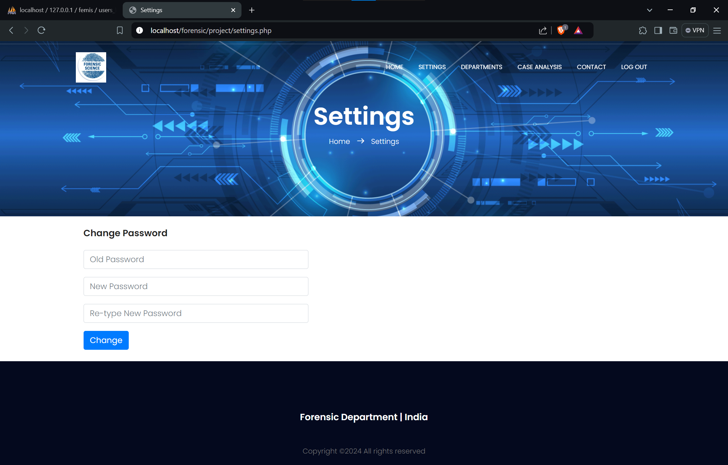

**Settings page (Figure-26)**

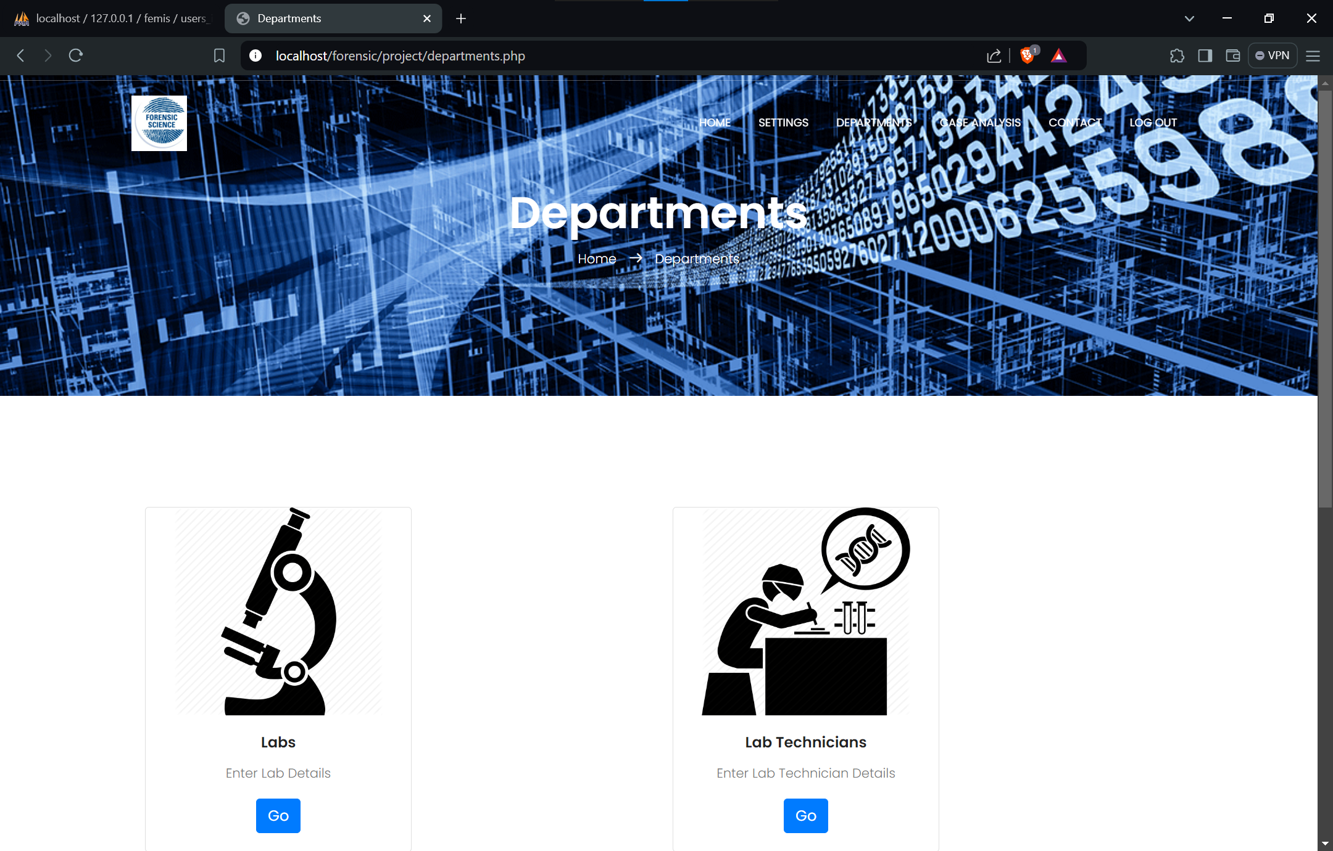

**Department info page (Figure-27.1)**

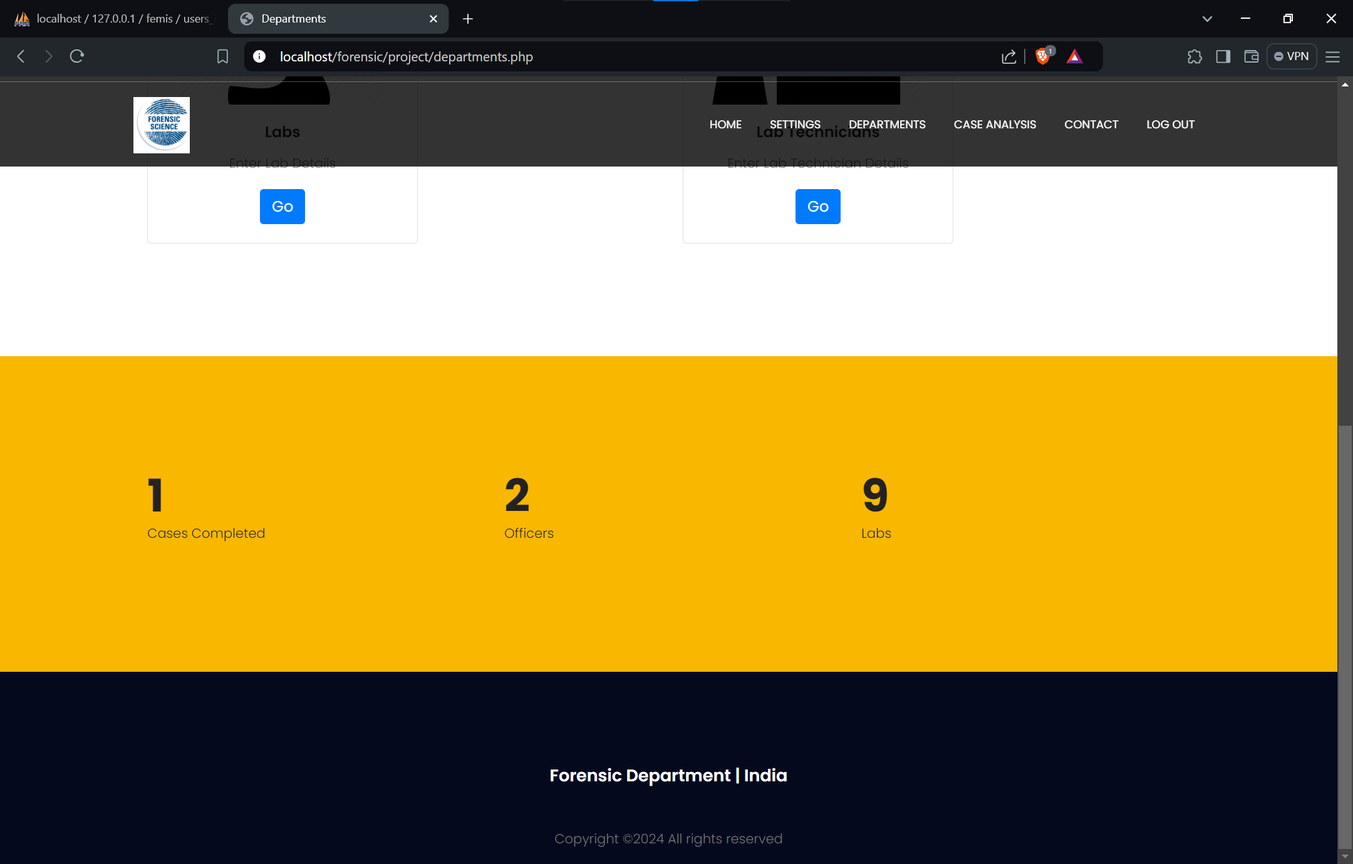

**Department info page (Figure-27.2)**

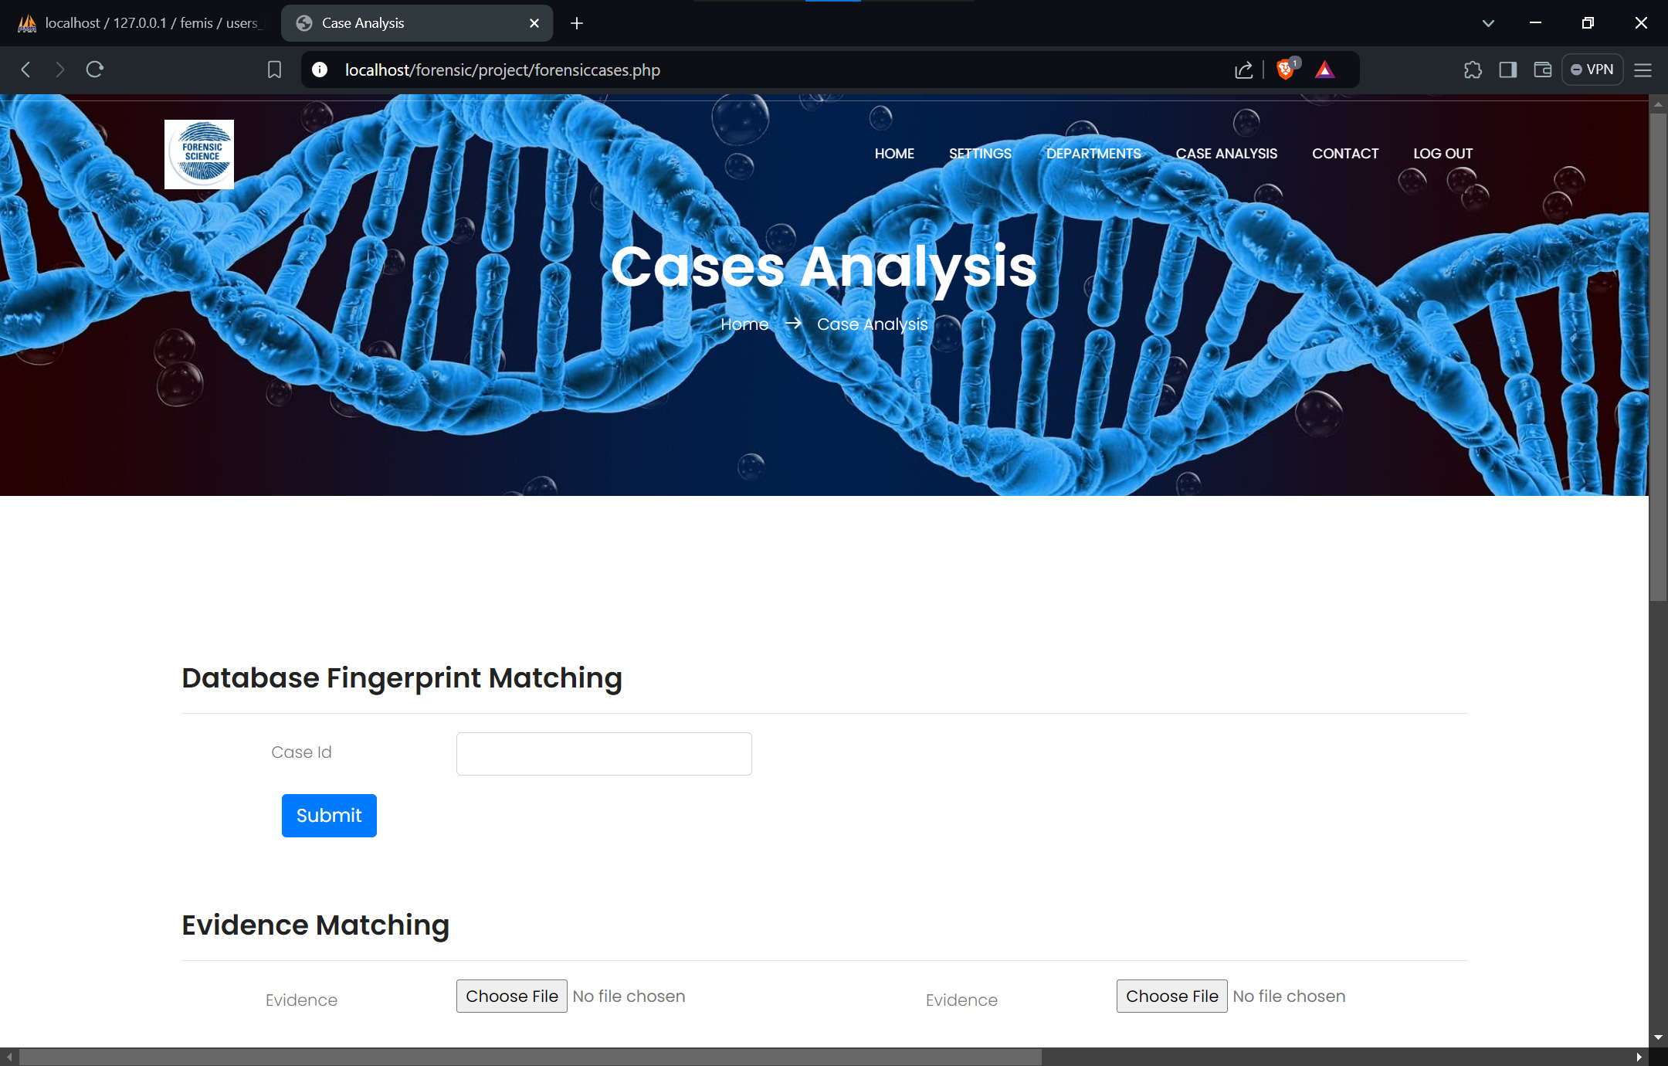

**Case Analysis Page (Figure-28.1)**

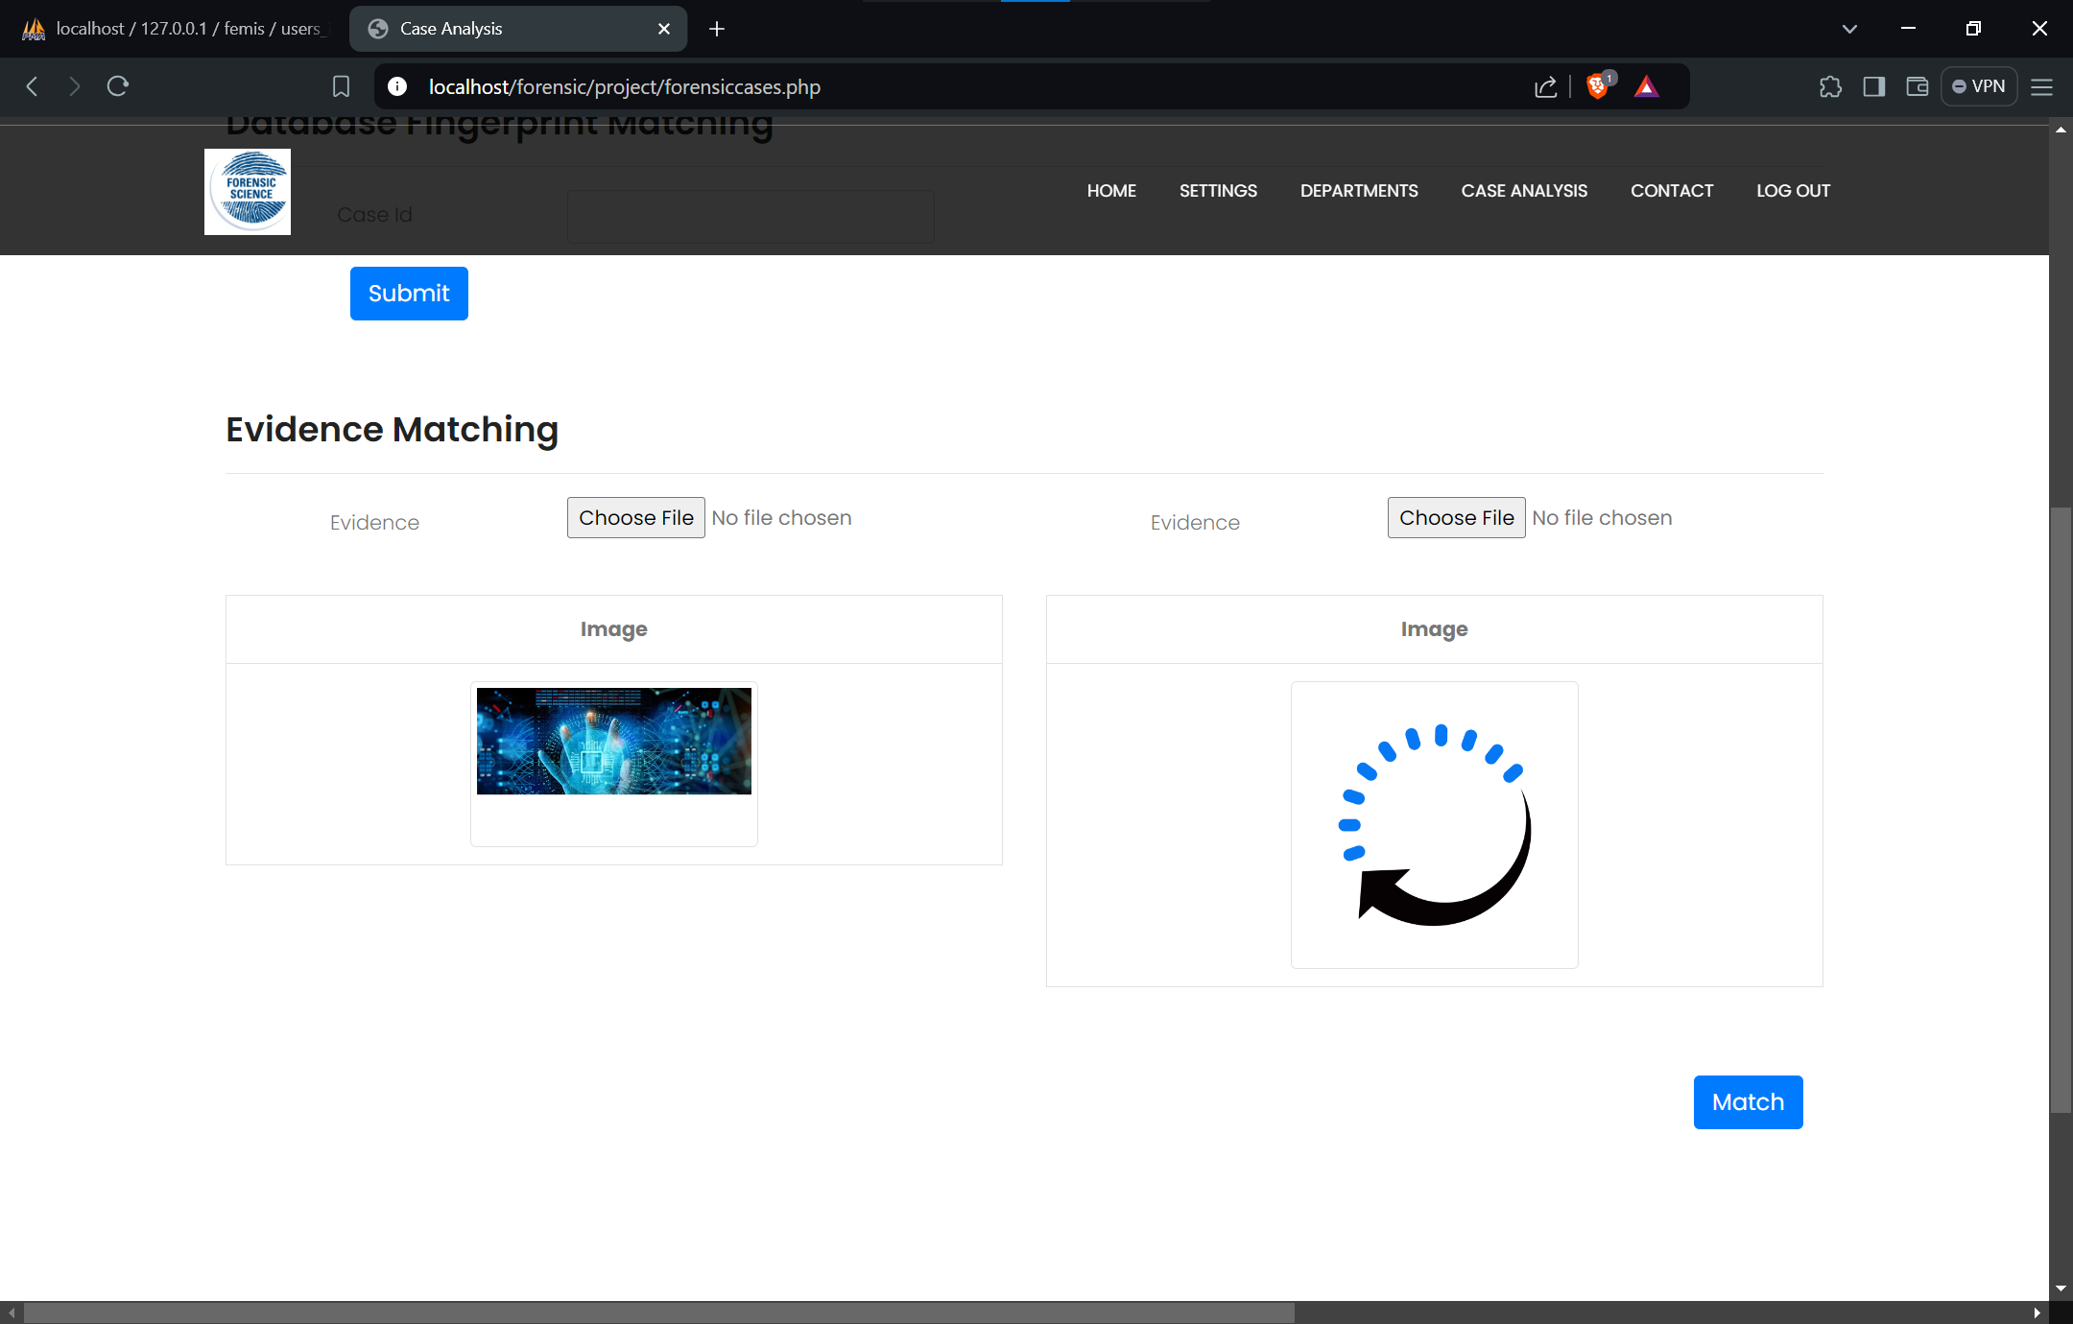

**Case Analysis Page (Figure-28.2)**

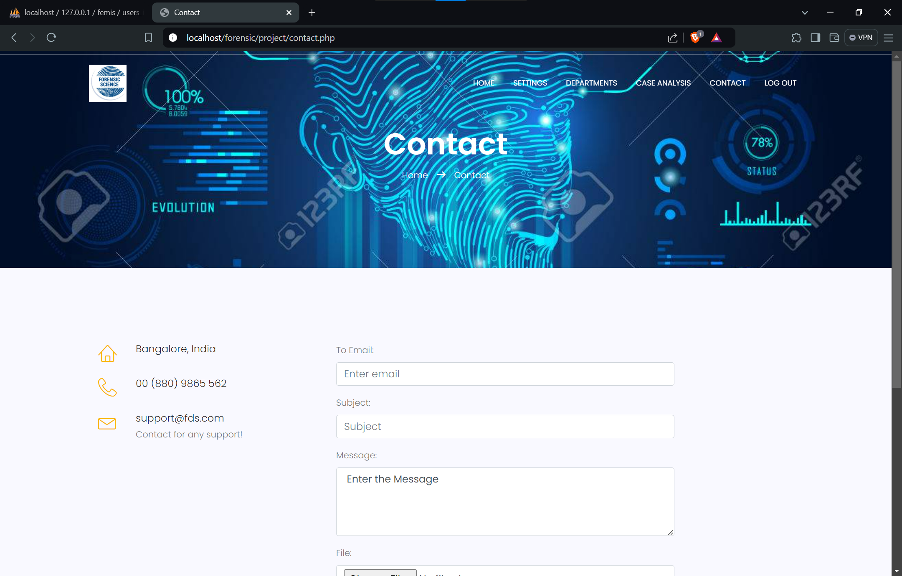

**Contact Page (Figure-29)**

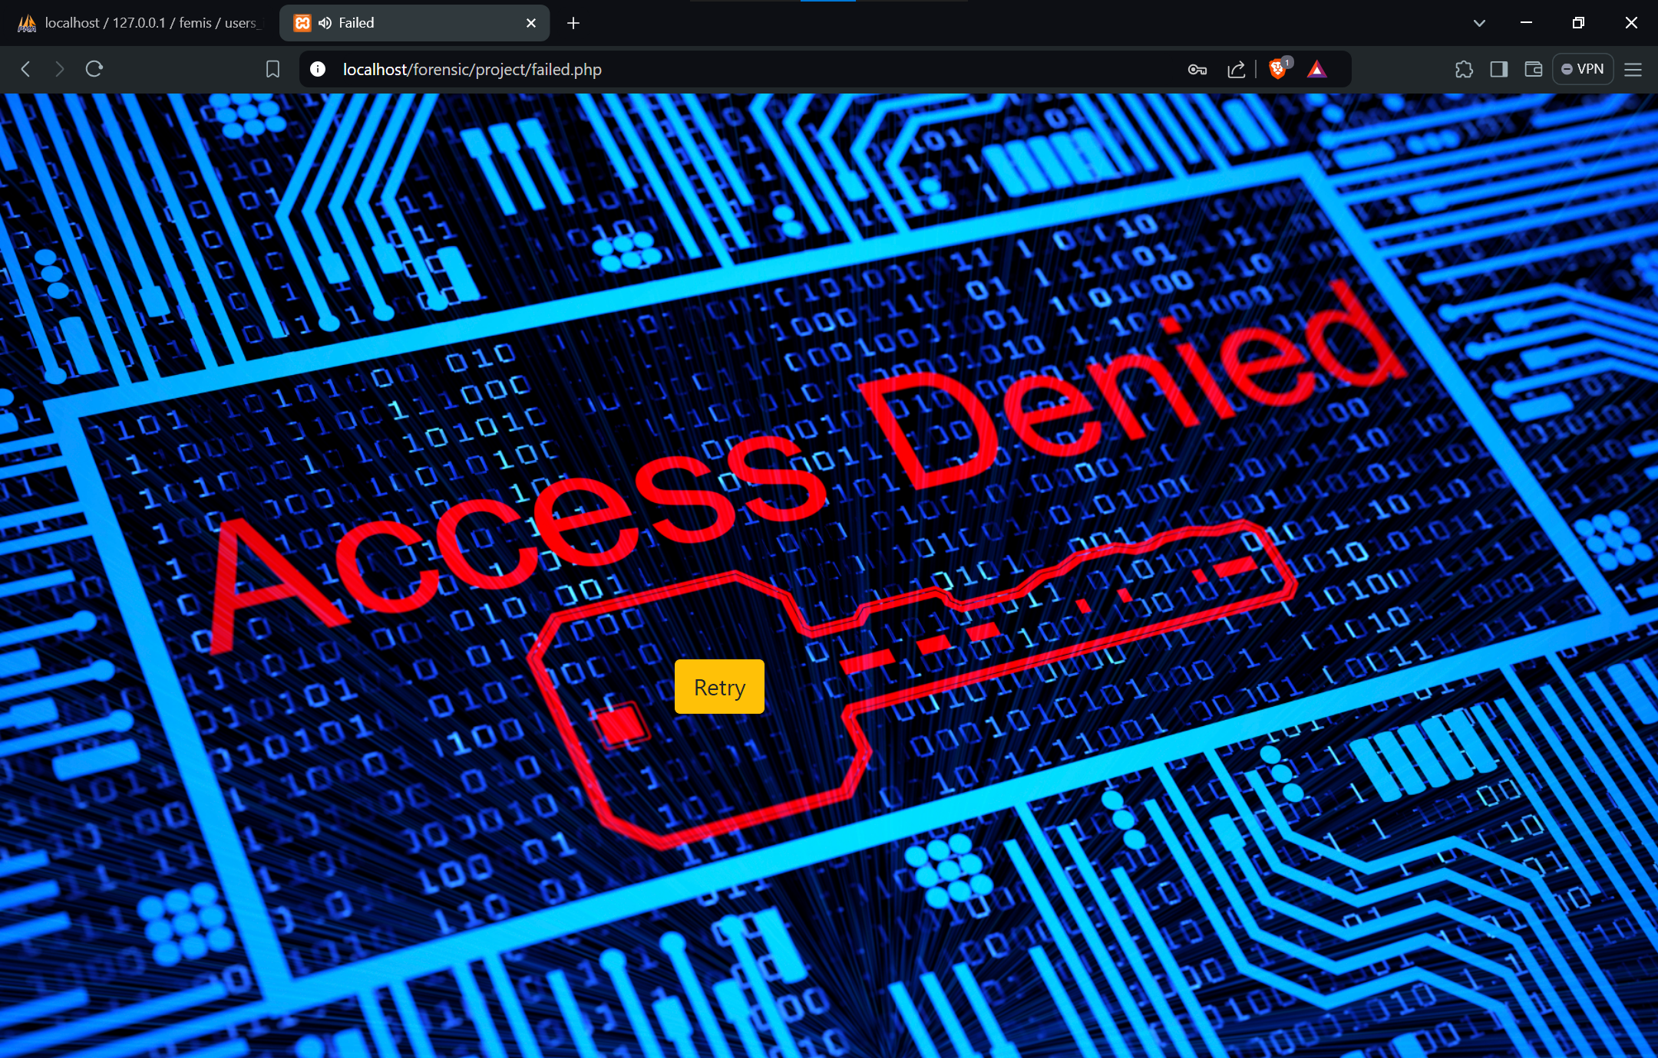

**Wrong Login Credential page (Figure-30)**

**References**

1. IEEE Journals
2. GitHub
3. GitCopilot
4. CHATGPT (OpenAI)

**Project Link**

[https://github.com/nithingowda381/DBMS-MINI-PROJECT.git](%20https:/github.com/nithingowda381/DBMS-MINI-PROJECT.git)

**Result & Conclusion**

The successful development and testing of the forensic case management system mark a notable achievement in the field of forensic investigations. This system effectively addresses the need for a streamlined, secure, and efficient approach to managing forensic cases and evidence. By incorporating key features such as secure user login, comprehensive case management, precise evidence handling, and robust administrative controls, the system significantly enhances the ability of forensic professionals to organize, track, and manage their work.

The rigorous testing phase has validated the system’s reliability and functionality, confirming that it meets the required standards for practical use. This success ensures that the system is well-prepared to support forensic investigations, offering improved efficiency and accuracy in case management. The system’s capabilities contribute to maintaining the integrity of evidence and documentation, which is crucial for upholding the standards of forensic work and ensuring accountability.

Looking forward, there are opportunities for further enhancements, including the integration of additional features based on user feedback and potential advancements in technology. Ongoing training and support will also be essential for maximizing the system’s effectiveness and addressing any future challenges.

In conclusion, the forensic case management system represents a significant advancement in optimizing forensic workflows. Its successful implementation promises to improve the management of cases and evidence, ultimately supporting the pursuit of justice and the effective resolution of forensic investigations.